Contact: Merit Software, 0044-2078375711
Date: 20120302
Pre-requisite:
- You have the database connection details
- You have the password for the destination database.
Follow below steps and change the details of the INI files
Note: Before you change any of the INI files, make sure to back them up in case you want to refer back to previous values
  - Go to the <Basepath>\INSTALL\ folder and open the SHARED.INI file
  - Look for the line starting with "CMEC1"===> which follows with the database connection string
  - Change the User, Server values to the new UAT database (Do not change the password, Leave it as Enc.[BDBPASSWORD])
  - Above this line, you should find another line starting with " CMEC0"===> and there will be a string starting with ENCMODE2: . This is the old encrypted password. Replace this string with the new encrypted password string generated above
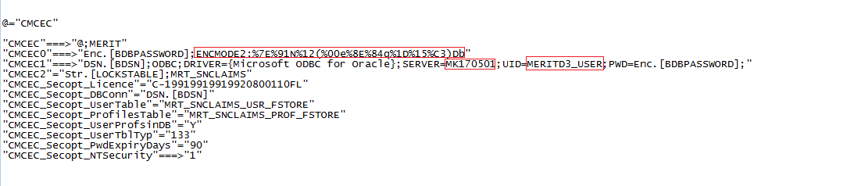
  - Save and close the SHARED.INI

- Run <BASEPATH>INSTALL\CLIENT\CM*.EXE to start up the system.
Enter the administrator login credentials and Click OK to logon to the system bypassing Single sign-on (only for Testing/installation purposes). Call Merit at +44207 8375711 if you do not know the username and the password.
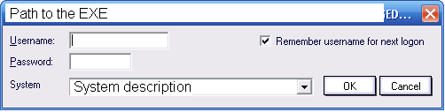

- You will get a log in progress and then will get the below sequence of messages. Click OK to both to continue
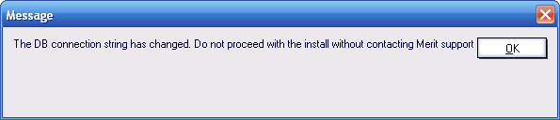
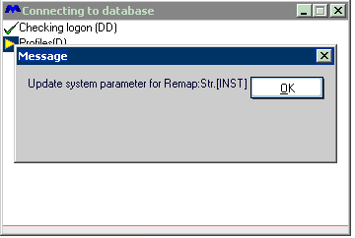
- Click on the Cross button on top right corner to close the progress dialog below to continue.
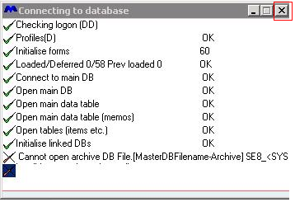
- On the main dialog go to Setup > System parameters
If you get below sequence of messages, Click OK to both to continue
If you get below message anywhere, click on No
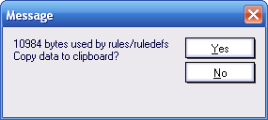

- Click on button ‘Change System Category’ on the top
- On the next dialog, check on the option ‘Confirm change system Category’.
- Click OK on the below Dialog.
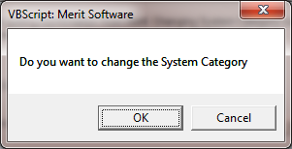
- Check the option ‘CLIENT_UAT’ and click OK.
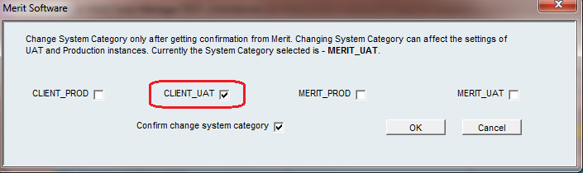
Find the Parameter Str.[BPATH] and confirm the CLIENT_UAT column has the correct value and make sure it ends with ‘\’. If not, double click on the record to update the value. Update the field CLIENT_UAT on the edit dialog and click OK to save
- Click OK to save the changes. Click OK to the System parameters dialog as well to save and exist.
- Go to File> Exit to log out from CM
- Logon again and make sure that you can logon to the system without any error messages such as below
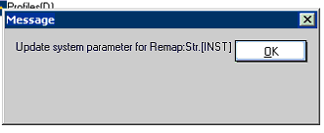

Update completed!

- Restart all of the services
- Ask all users to log back to application.

