ETD Files not received/P1P2P3 files not received

- Whenever support team receives an email from OPs team that they have not received ETD files or P1P2P3 files for all regions for a particular day. Then we need to follow the process as below.

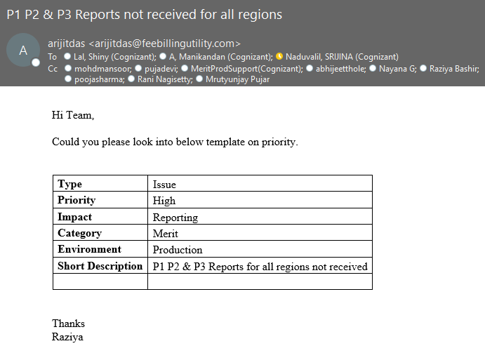

- Support team will triage the ticket and login into PROD server 18.19 to check the ETD files

- Firstly we need to check the files in D: Drive-> Merit ETD->Data->ASIA,EUROPE,FRANCE and UA region wise 14 files has to be in processed folder as shown in below screenshot

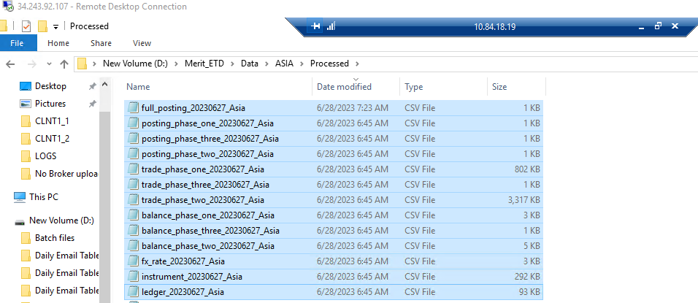

- If you don’t find the files in Processed folder, then we need to login into SFTP through WinSCP and check if the files are available in the SFTP path (WinSCP/SFTP login procedure KB attached for reference).

- If we found the files in SFTP, we need to download it in the local desktop.

- To upload these files in processed folder, we need to stop the region wise services and CLNT1_2 service and paste the files in data folder as per region wise. Once we paste the files, we need to start all the region wise services and CLNT1_2 service.

- If we found the logs in processed folder and the files are not moving to sent reports, then we need to go to D: Drive->Merit->LOGS->CLNT1_2 and check if we find any errors in the logs

- If you find any errors in the logs, then review the and try to find out the exact issue

- If you are not aware of the error. Please reach out to L3 engineering team and try to fix it ASAP

- Incase if you find in the errors that any specific region file is empty. Then try to check with Ops team if the region has holiday that before day

- If yes, the region has holiday, and any file is empty. Then open the same file from the previous day files and try to copy 2-3 trades from it and paste it in the empty file and restart the process. Hopefully this will resolve the issue
- Incase, in the errors it says the file size is big for any specific file for any region. Then open that file and remove all the trades and keep only 2-3 trades in it and restart the process. Hope fully it will resolve the issue.

- Monitor the region wise and CLNT1_2 logs until the files get moved to send reports. As shown in the below screenshot

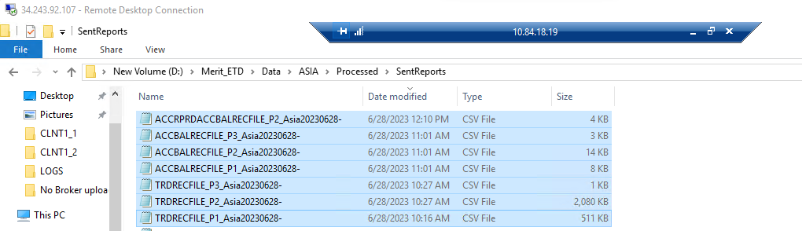

- Check with user and get confirmation if they received all the files for all regions.

- If the user confirms that they have received all the ETD files for all regions. Then close the case.

- In case these troubleshooting steps did not resolve the issue. Please reach out to L3 engineers and try to fix the issue ASAP

