ETD Full Posting File Trim
This activity needs to be done once a day to ensure that the ETD reports are successfully uploaded in the server without any delays on a daily basis.
- Login to Cisco Any Connect with your credentials.
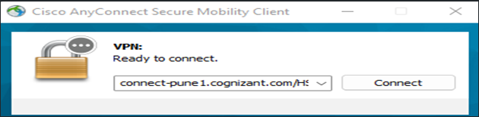
- Login to HSBC jump server (34.243.92.107)
- Login to RDP and Production server (10.84.18.19) from inside the jump server by using Service Account with below creds
- MERIT_PROD
- M@qazwsx123
- Go to Services and stop (i) CLNT1_2 & (ii) CMSRVRHSBC_HF_SERVICE_ASIA services
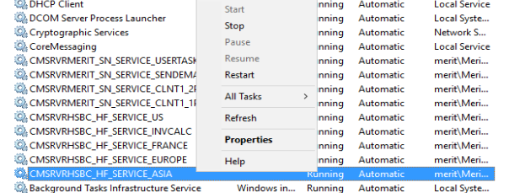
- Select the Windows explorer and go to D:\Merit ETD\Data\Asia\Processed and open the full_posting_YYYYMMDD_Asia file.
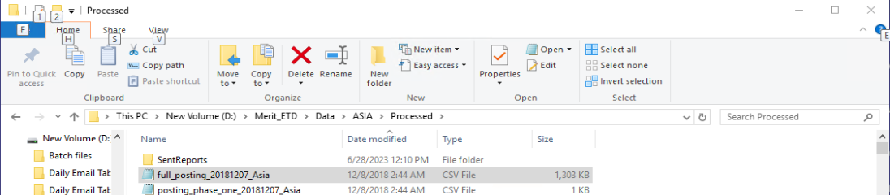
- We need to only keep the first two trades of the file and delete the other trade files.
PN: To identify the start and end of 1 trade file, note that the trade files will always begin with the name of the country and ends just before the same name of the country comes up again which indicates that it is the prefix of the next trade file.
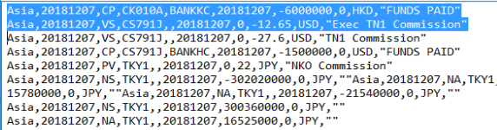
- Once you are done deleting the trades, please note that the file will always end with the suffix FINISH followed by the number of trades it was present in the sheet. Please remember that since you deleted all the trades apart from the first two, you need to change the trade number in the edited sheet and it will be FINISH 2
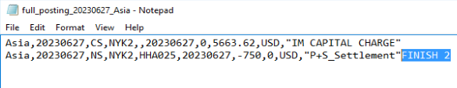
- Please save the file. Make sure you do not change the destination of the file. It needs to stay in the Processed folder.
.
- Repeat all the above steps for the remaining ETD countries (Europe, France & US).
Clearing CLNT1_2 folders from Temp in PROD server Using MERIT_PROD Service Account:
- Now login into the Prod server 18.19 by using below service Account ID and Password
- ID – MERIT_PROD
- Password – M@qazwsx123
- After logging into the prod Server – 18.19, now run the command %temp% using run command or navigate to the below path –

- After running the command a folder will get pop up as shown below
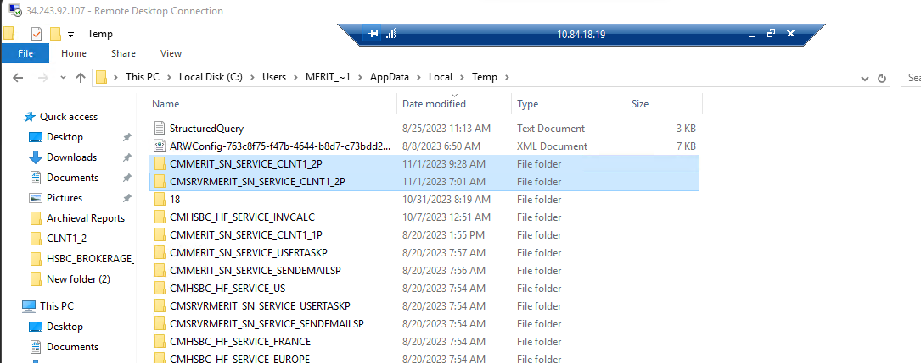
- Now shift+delete the above highlighted clnt1_2 folders from the temp folder.
- Start the CMSRVRHSBC_HF_SERVICE_ASIA service and all ETD countries (Europe, France & US).

- Now start the CLNT1_2 service, again after 2 folders which were deleted will be created again automatically

