Feed Files Extraction

- A request to extract and send feed files from the production server is common from the Meritsoft L3 team. In such a scenario, the requester will provide the COB date. If there is no mention of such dates, kindly send an email to the requester and get the information before proceeding to the extraction.

- Login to Cisco Any Connect with your credentials.

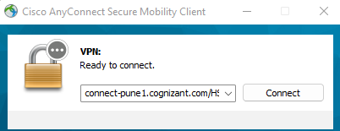

- Login to HSBC jump server (34.243.92.107)

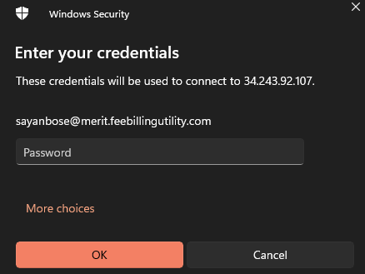

- Login to RDP and Production server (10.84.18.19) from inside the jump server.

- Open Windows Explorer D:\Merit\Data\CLNT1_1 and in the Search box enter the COB Date provided by the requester.
For example, if the user has mentioned that he needs the feed files for 16th of June,2023, then in the Search box mention 20230616.

- Once the files come up on the screen based on your search, you will find OUT files as well as .zip files. We need to copy the OUT files only.

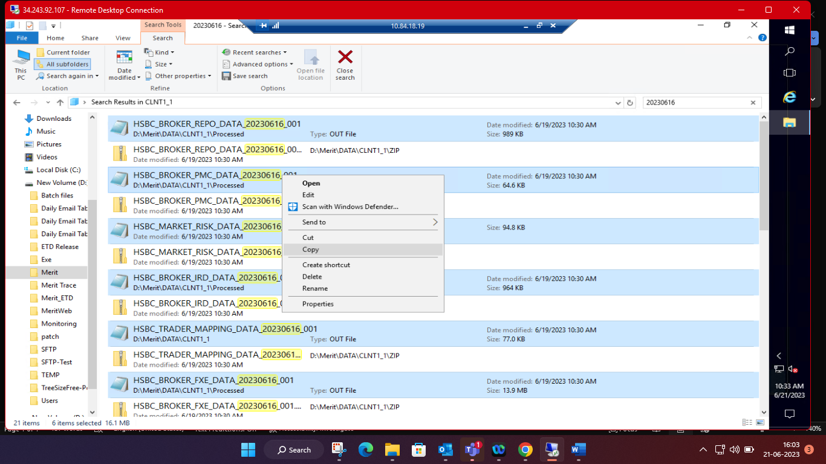

- Create a Zip folder on your desktop, rename it to FeedfilesYYYYMMDD and paste all the copied files in the Zip folder.
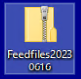

- Copy the Zip folder and paste it in your jump server desktop.
- Open your Meritsoft outlook inbox from the browser of your jump server and send the file to the requester.

