Health Check Report:
This report needs to be sent 2 times in a working day, one during the start of the day(SOD) and another during the end of the day(EOD)
- Login to Cisco Any Connect with your credentials.
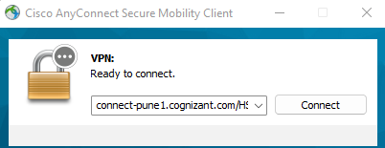

- Login to HSBC jump server(34.243.92.107)
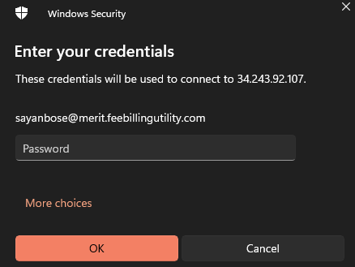

- Login to RDP and Production server(10.84.18.19) from inside the jump server.
- Open the thick client(D:/Merit/Install/Client) and login with the shared credentials.
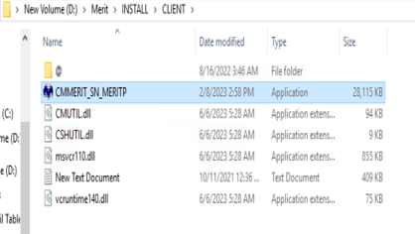

- Go to Static Data – System Options and then select Service Monitor from the dialogue box
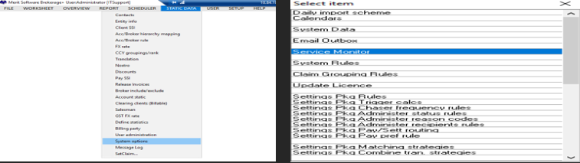

- Select CLNT1_1, click on Amend take the screen shot and attach it in the email with the date and time.

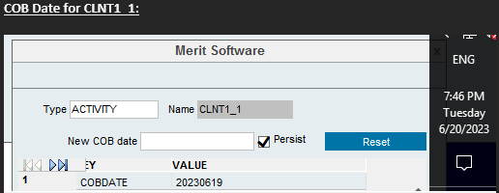

- Repeat the same for CLNT1_2, click on Amend take the screenshot with the date and time and attach it in the email.

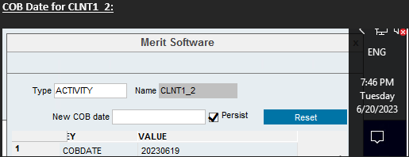

- Please type the COB Date in YYYYMMDD format in the email
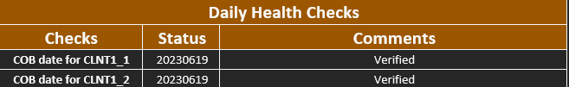
- Close the thick client.
- Go to the Start button and select Services
- Check whether the CLNT1_1 and CLNT1_2 services are running or not. If all services are running mark them as Verified in the email.
PN: All services which are marked as automatic should be running. If anything is inactive, please inform the team so that corrective actions can be taken.
- Go to D:/Merit ETD/Data/Asia/Processed/SentReports select all the files of the date which you are writing the email, take a screenshot and attach it in the email.
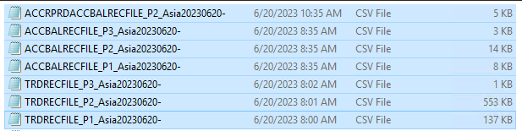

Repeat the same step and attach screenshots in the email for remaining countries in the Sent Reports folder(Europe, France and US).

PN: There are three kinds of ETD files which are uploaded on a daily basis.
- Trade recon files
- Balance recon files
- Accrued Files
All the above files need to be there, only then we can confirm that the ETD files have been uploaded for the day. Please check the logs and see the stage if its incomplete and provide an update to your supervisor in case the ETD files are incomplete.
- Once all the ETD screenshots have been pasted in the email, please mention that the ETD files have been uploaded for T-1(th) date.
For eg, if the files in the screenshot show the date 20th of June 2023, then in the email you must write that the ETD files have been uploaded for the 19th of June,2023.
- Go to Start and open SQL
- Click on New Query, type the query select MRTCOBDATE, MRTPRODTYPE, COUNT(1) from MRT_SNCLAIMStrades where MRTPRODTYPE <> 'ETD' AND (MRTPERIOD = 202305 OR MRTPERIOD =202306) GROUP BY MRTCOBDATE, MRTPRODTYPE ORDER BY MRTCOBDATE DESC in the SQL query page and click on execute. There should be 7 files coming out of T-2(th)date. Please take a screenshot and attach it in the email.
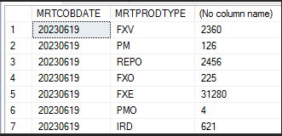
For eg, if the files in the screenshot show the date 21th of June 2023, then the screenshot will show 7 latest OTC files of the 19th of June,2023 and in the email you must write that the OTC files have been uploaded for the 19th of June,2023.

- Go to Task Manager-Users and make sure that inactive users are disconnected from the server.
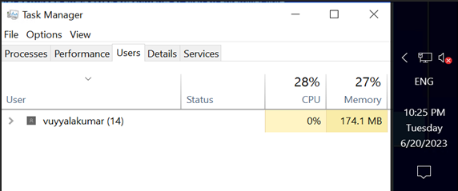
- Go to Start and open Performance Monitor. We need to make sure that the Performance Monitor is running and has not been stopped. If stopped, kindly start the monitor again, take a screenshot and attach it in the email.

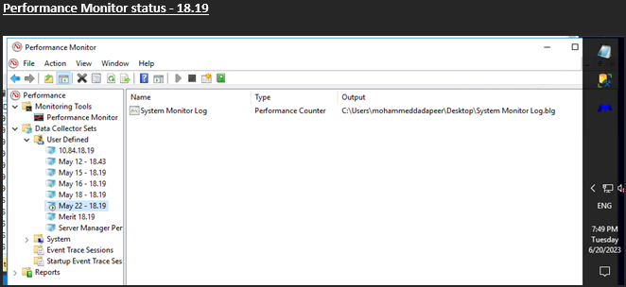

- Logout from the Production1 server.
- Go to Start inside the jump server and login to Production2 server(10.84.18.43).
- Go to Services.
- Check invcalc, matching, backpop and calc services if they are running or not. If yes mark the service as Verified, if not report it to your supervisor.
PN: All services which are marked as automatic should be running. If anything is inactive, please inform the team so that corrective actions can be taken.

- Go to Task Manager-Users and make sure that inactive users are disconnected from the server.

- Go to Start and open Performance Monitor. We need to make sure that the Performance Monitor is running and has not been stopped. If stopped, kindly start the monitor again, take a screenshot and attach it in the email.
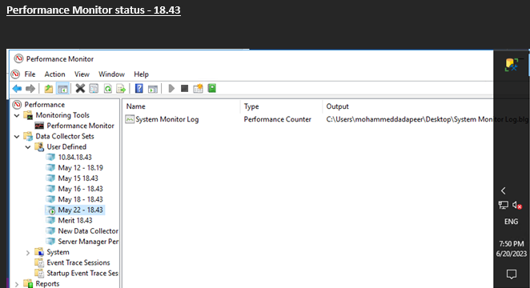
- Once done, send the email to gavaskar.koppula@cognizant.com & JohnHG.Rocha@cognizant.com keeping L2.ProdSupport@meritsoft.com in cc

