How to Provide or Revoke Merit access to Requester

- Support team will receive service request from Utility support Team as shown in below screenshot. We need to follow the process as follows
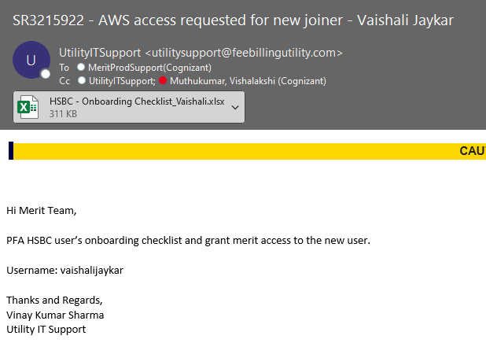
- Once we receive this type of service request from Utility support, we need to check if the attachment is attached or not. If not attached, we can request them to provide it.
- If the user has attached the excel sheet in the email, we need to open and check all the required details in it as shown in the below excel sheet
- Now triage the service request as task low and keep it in L2 Prod support queue.
- Now open the attached excel sheet and check what access we must provide user and for which environment we need to provide.
- Login into the respective environment server by looking in to the excel sheet if it is prod login in to both pro servers and provide the access.
- If the access is needed for only PROD and UAT, provide only for PROD and UAT environments

Process to Provide access in all the three environments

- Login into the PROD servers 18.19 and 18.43 via Jump server and open Thick client application
- Once login into Thick Client, go to Users-> users administration, a window will be populated as shown below
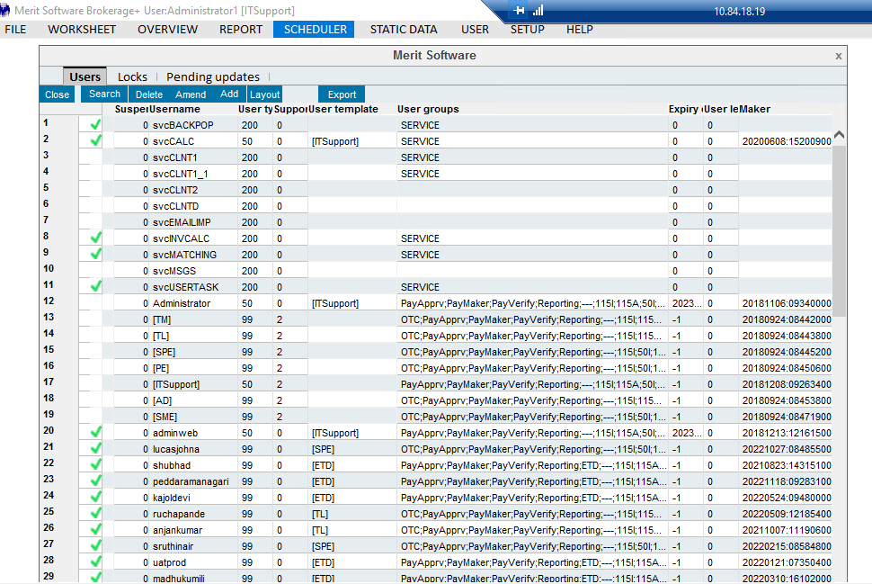

- Now click on add option, another window will be populated as shown below
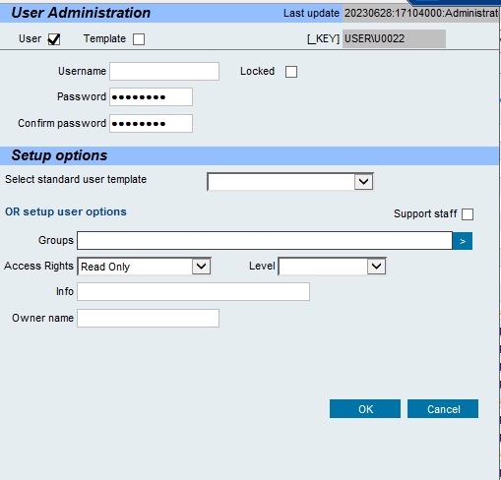

- In the username tab provide the username provided in the service request email
- In the password tab, please provide the first name of the user@123 and confirm same password
- In the select standard user template choose the template provided in excel sheet
- For example, if they mentioned as ETD in excel sheet chose ETD from the dropdown as shown in the below screenshot
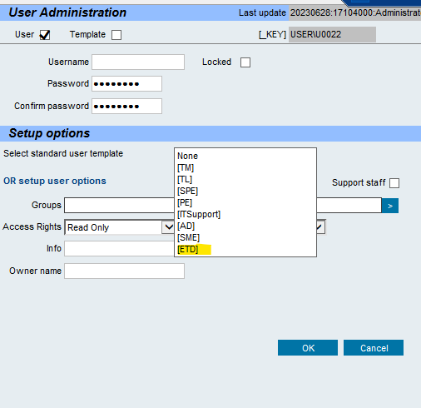

- After selecting the standard user template just click on OK button. The user name will be populated as shown in below screenshot which means user has given Merit access.
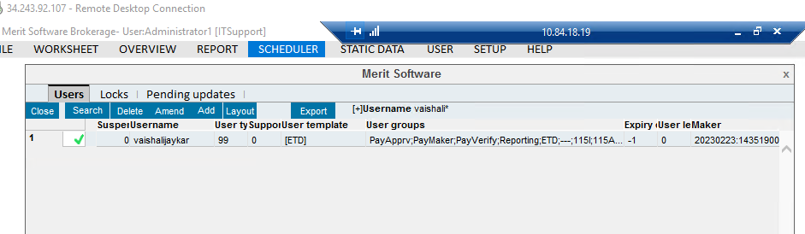

- Same process has to be followed for UAT and Pre-Prod Environments for providing merit application access to users.
- Once the merit access has been provided to users. We need to send a separate email to them with the username, Password and Merit application login links as shown in below screenshot
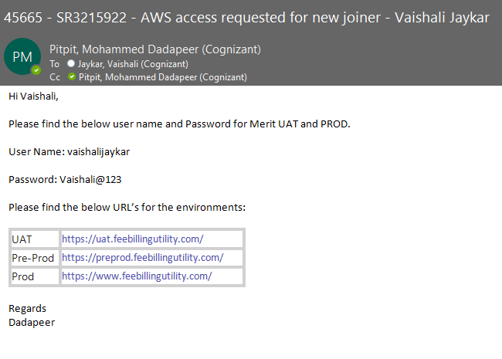
- After sending an email to user with credentials, support team can close the Zendesk ticket

