How to send HSBC OPS users list

- Every month on 1st Business Day, support team will check the HSBC OPS users list from Production server through Merit Website and Thick client and share it with Ops team to review.

How to pull the HSBC OPS team user list through Thick Client

- Login into Thick Client in HSBC PROD Server 10.84.18.19 and navigate to the below path to open thick client

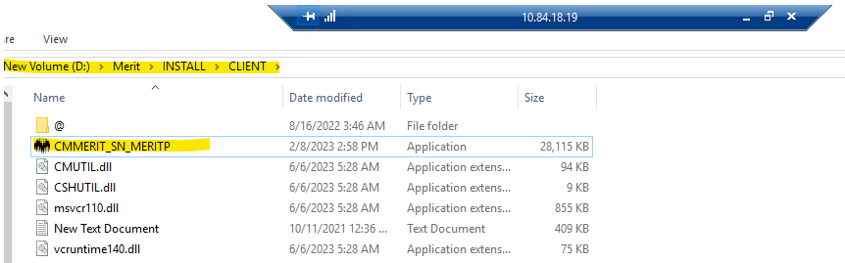

- To login into thick client use the below user ID and Password
User ID – Administrator or Administrator1
Password - sunshine1

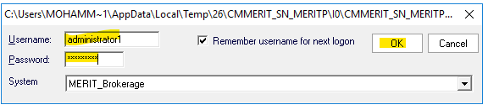

- After logging into thick client go to user and in that click on user administration. A window will get populated as shown below

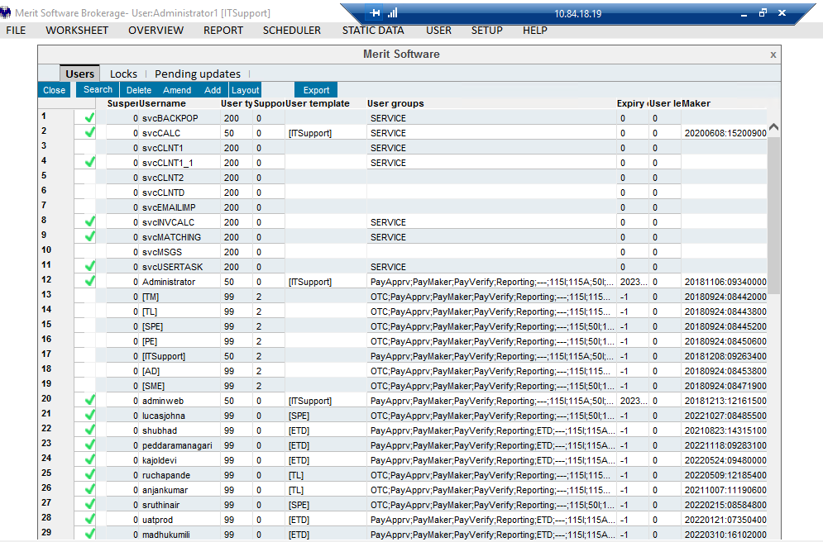

- Now click on search button and make sure no filter is applied. If you find any filter, just click on reset and click on search as shown below
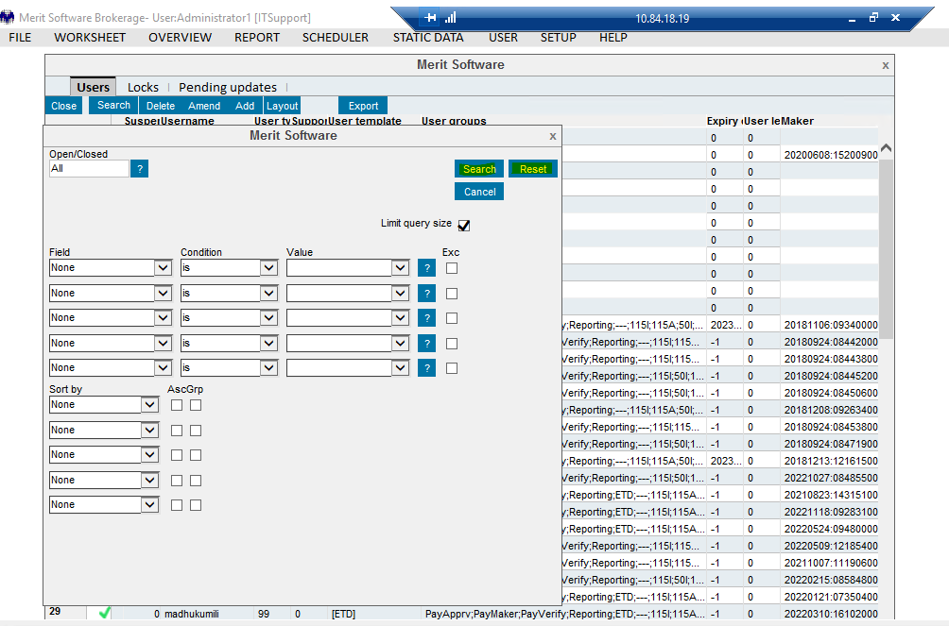
- Once we click on search, we can see all the users list in the page, who are available and active. Now click on export and wait for 2 mins for the file to get downloaded in your downloads folder.

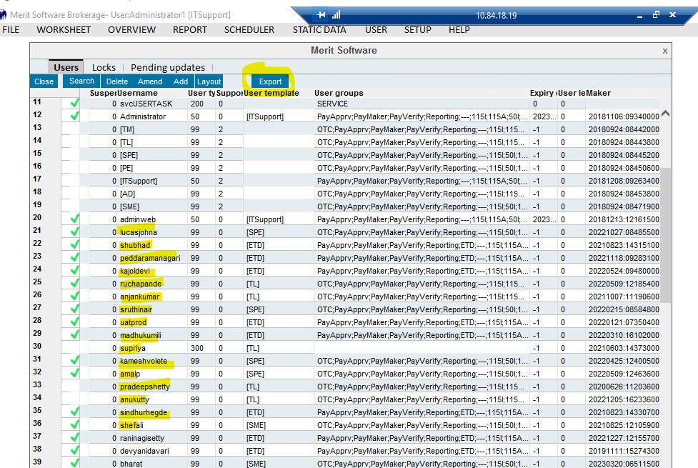

- Now go and check for the Ops users list file that has been downloaded in your downloads folder as shown below

How to pull the HSBC OPS team user list through Merit application

- Login into Merit application, with the below credentials as shown below.

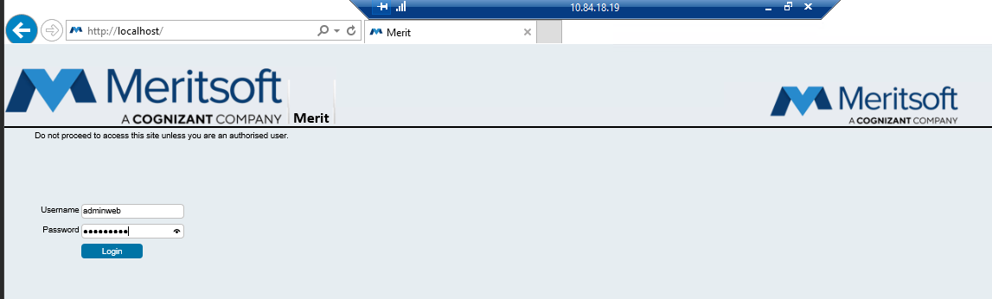
- To login into Merit application, use below credentials as shown below

User ID – Adminweb or Adminweb1
Password – sunshine1

- After logging in to the merit application, on the top left corner click on the setting symbol and go to user administration as shown below

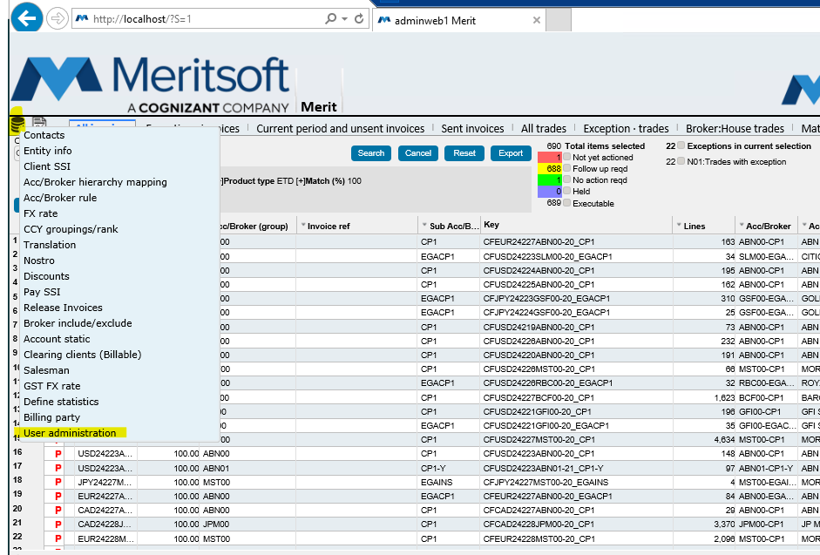

- After clicking on user administration, a window will be populated as shown below

- Now click on search button and make sure no filter is applied. If you find any filter, just click on reset and click on search as shown below
- Once we click on search, we can see all the users list in the page, who are available and active. Now click on export and wait for 2 mins for the file to get downloaded in your downloads folder.

- After clicking on export, you will receive a popup that file is exporting, don’t click on cancel. Allow it 2 mins so that the file will get downloaded as shown below
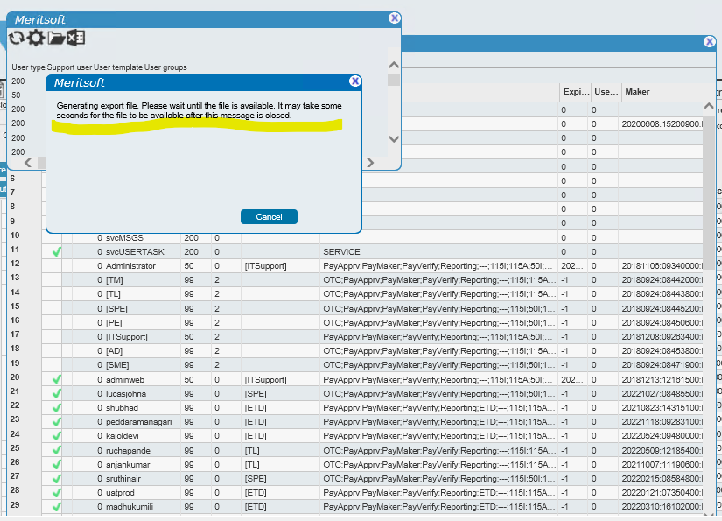

- Now go and check for the Ops users list file that has been downloaded in your downloads folder as shown below

- Once these 2 files are downloaded, send an email to the ops team managers to review the lists and confirm if any user access must be given or revoked as below
