HSBC DROP RELEASE PROCESS

- Support team will perform Drop release along with Engineering team on all the 3 environments for the Brokerage Servers.

- 10.84.30.11 – UAT Environment
- 10.84.32.11 – Pre-Prod Environment
- 10.84.18.19 – Production Server1
- 10.84.18.43 – Production Server2

PRE- DROP Release Activities

- Once we receive an Drop release plan from engineering team, we have to create a routine Meritsoft Change request in Zendesk - #44964, #45829, #46190.
- After creating the Change Request, triage all the emails related to Drop release from Start to end.
- Now we must send an email with release summary to Naveen Srinivasa for approval as we are proceeding for the Drop Release as shown in the below screenshot.

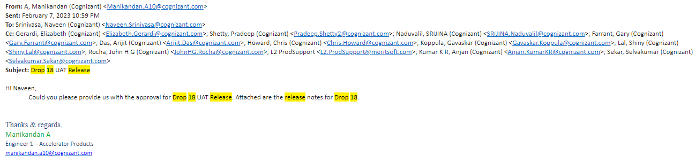
- Once we receive an approval email from Naveen Srinivasa as shown in the below screenshot
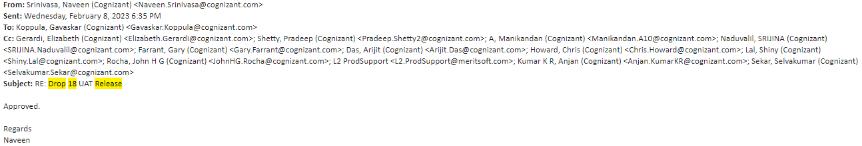

- We have to send an email to utilitysupport@feebillingutility.com for DB refresh, as shown in below
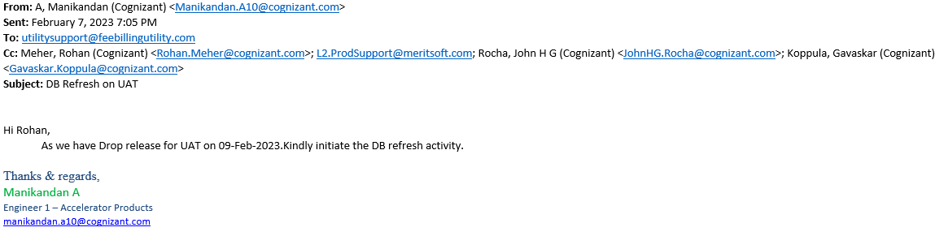
- Once we get DB refresh activity completion email from utilitysupport@feebillingutility.com or Parallelly we need to do Application refresh in the respective Server

Application Refresh and Data Backup Process as follows:

- Before Doing Application, refresh and taking Data Backup, we have send an email to hsbc.all@feebillingutility.com team as shown below

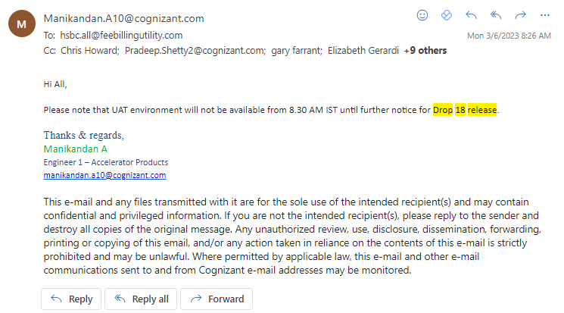
- After sending the above email wait for 5-10 mins, so that the users can save their work, before the application goes down.
- Now, we have to login into the Jump server and login into the respective server for which we are doing drop release.
- Go to the services and stop all the Merit Automatic Services which were highlighted in the below screenshots.
- 10.84.18.19 – Production Server1

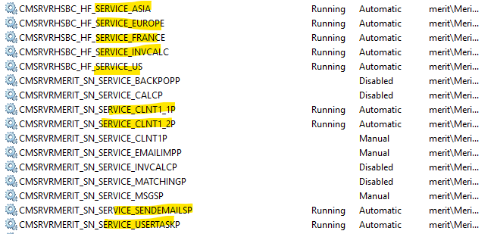
- 10.84.18.43 – Production Server2

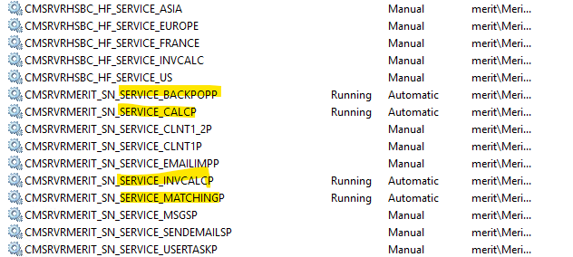
- Now stop all the Application pools and web services in IIS which we highlighted below in both production servers.

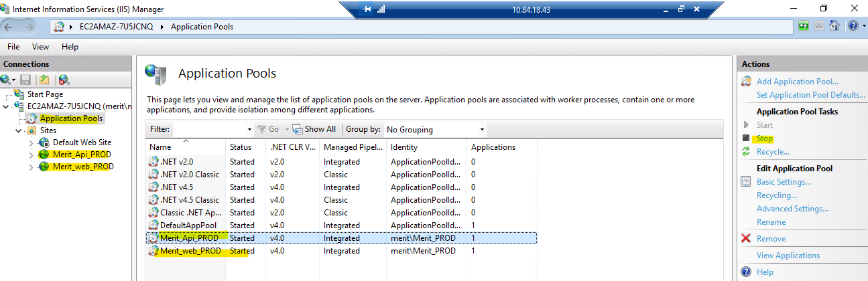
- As we already stopped all the merit related services. Just cross check again services in Task manager if any of the service is running. If you find it, please end the task.
- Now login with admin ID - Merit_UAT or Pre-Prod or PROD and clear the files start with C in Temp
NOTE: Login Id and Password for Service account as follows:
ID: Merit_UAT, Merit_PRE-PROD, Merit_PROD
Password: M@qazwsx@123
- Now create folder called Backup with Drop release date in D: Drive-Temp and create 3 subfolders inside Backup folder as Merit, Merit ETD and Merit Web as shown below.
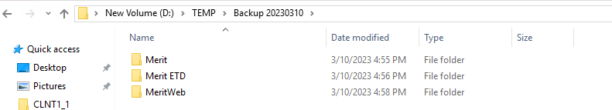
- Now go to D: drive-Merit-copy all the folders apart from data and logs folder and paste it in D: drive-Temp- backup-Merit.
- Now go to D: drive-Merit ETD -copy all the folders apart from data and logs folder and paste it in D: drive-Temp- backup-Merit ETD
- Now go to D: drive-Merit web-copy only folders Temp, Web API, Web MVC and few other files as shown below and paste it in D: drive-Temp- backup-Merit.
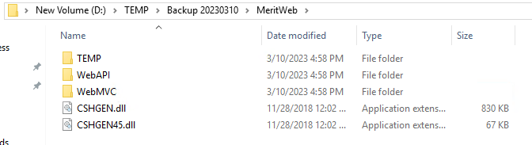
- Once copying all files from D: Drive – Merit, Merit ETD and Merit Web to D: drive Temp-backup- Merit, Merit ETD and Merit Web. Now delete the files that we copied from D: drive Merit, Merit ETD and Merit Web apart from Data and Logs.
- If the drop release is for UAT and Pre-prod, post deletion of files from D: Drive – Merit, Merit ETD and Merit Web. Now copy the same folders from PROD server and paste them in D: Drive – Merit, Merit ETD and Merit Web.
- NOTE: While doing application refresh to PROD Drop release, we will only take backup of folders from D: drive. We will not delete the folders which we have copied from the D: Drive-Merit, Merit ETD and Merit Web.
- Once this activity is completed on the respective server. Start all the services which we have stopped. For prod we need to start in both production servers.
- Start all the Application pools and web services which we have stopped before application refresh and backup.
- Now try to login into the merit application and thick client, If you are able to login respond to all the user that the respective environment is up and running fine. So that all the users can access
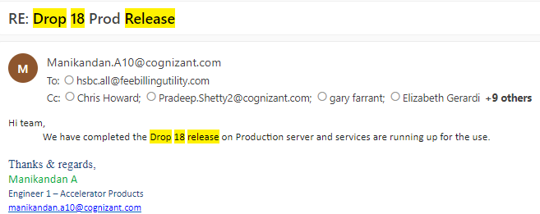

DROP RELEASE Activity
- On the day of DROP release activity login into appropriate Server through Jump Server.
- Check all the services and Application pools Web services and Logs, Make sure everything is up and running fine without any errors or issue.
- Once the L3 team joins the call, send an email to All Application users that the Merit application for the respective server will be down due to Drop release activity.
- Wait for 5-10 mins after sending the email and follow the below process for doing the drop release.

- Inform L3 Engineer whoever in the call that we are going to start the drop release.
- Stop all the automatic running services in the respective server where we are performing drop release. If it is PROD, then we need to stop both the servers.
- Stop all the Application pools and Web services in IIS application in the server.
- check in task manager if any services are running, if running end, the task
- login with admin ID - Merit_UAT or Pre-Prod or PROD and clear the files start with C in Temp
- NOTE: Login Id and Password for Service account as follows:
ID: Merit_UAT, Merit_PRE-PROD, Merit_PROD
Password: M@qazwsx@123
- Make sure to Sign off all the other users before starting the release process.
- Now inform the L3 Engineer who is in the call that all these activities are completed. And follow the steps which will be suggested by L3 engineer from the DROP release Package and Documents.

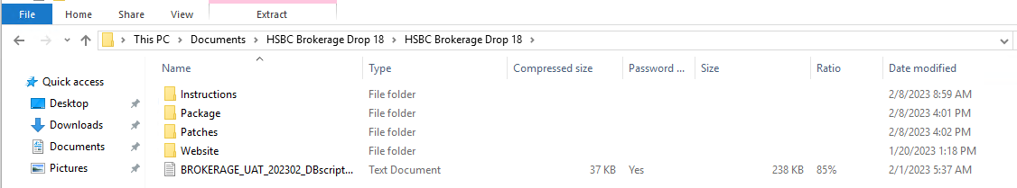
- We have to download the above HSBC_ DROP_RELEASE_ PEACKAGE from SFTP
- Which contains Instructions, we have to read the instructions carefully before the drop starts.
- The package also contains Package, Patches and etc. as shown in the above screenshot.
- Now proceed for the application installation as per the instructions provided by L3 engineer and Document which was provided in pack.
- Now we have to open Command Prompt and access merit Thick client by giving below commands as shown in below screenshot.

Application Installation:
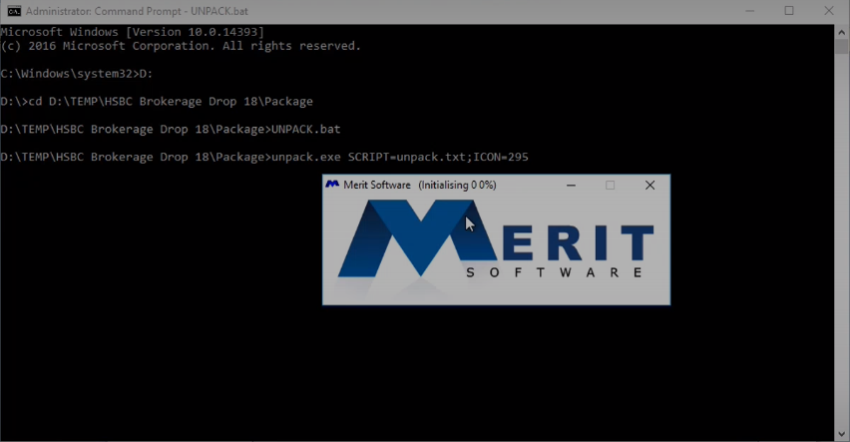
- A pop will come after this and we need to click on update existing system as shown in below screenshot.
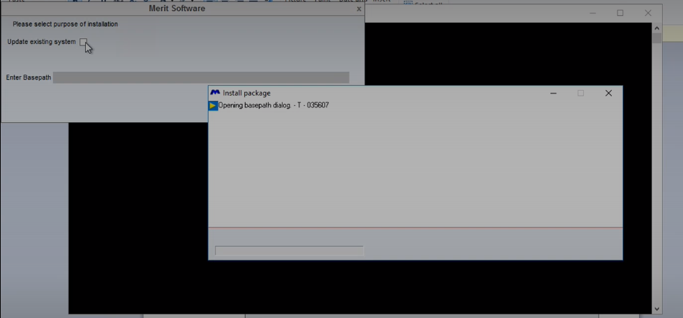
- And the we need to give the base path as D:\Merit\ and click next
- Now click on the automatically ODBC first option and click next as shown in below screenshot.
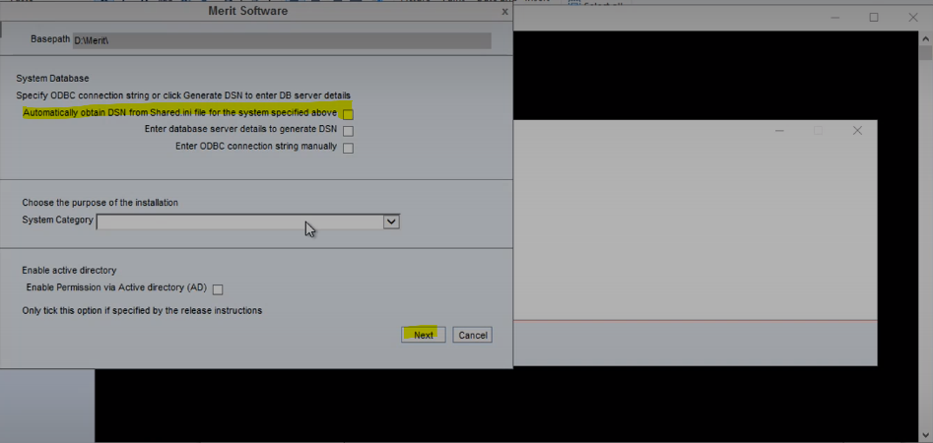
- Then we need to click on Test. Once we click on test we will get a pop as Connection test is OK. Now click on OK as shown in below Screenshot.
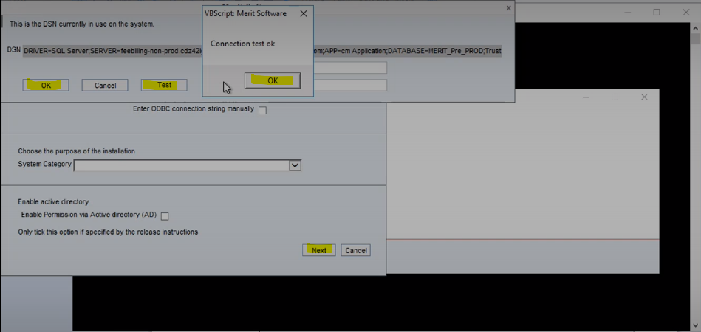

- Now click the Drop down and select first option as shown in below figure and click next.
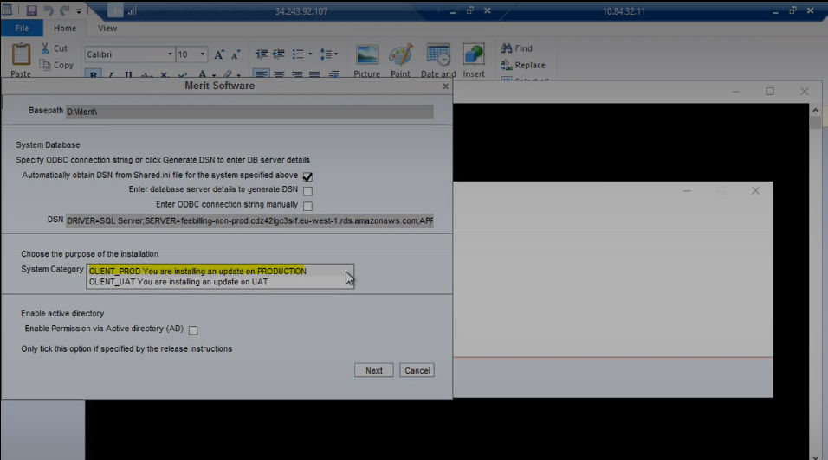
- Once we click on next a window will get pop up by loading all the patch updates to Thick client.
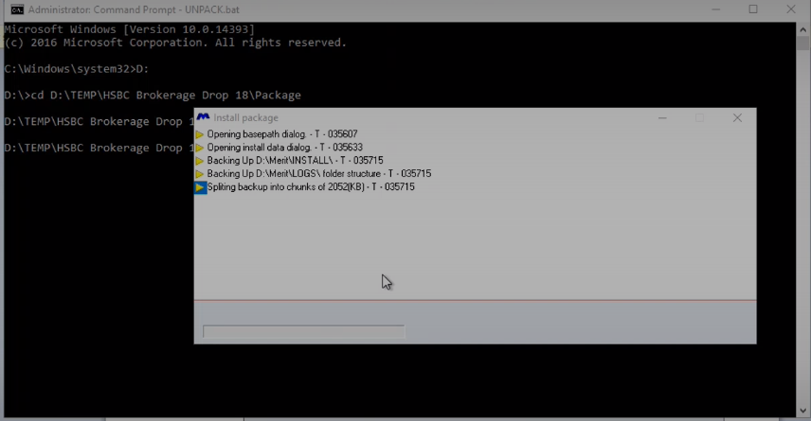

- This indicates the package is being installed and it will take 15 – 30 mins and once it is done and it will as shown in below screenshot.
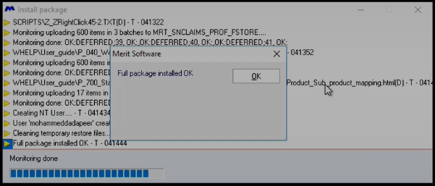
- Now you will get another pop asking to cancel. Done click cancel, we need to wait for sometime.
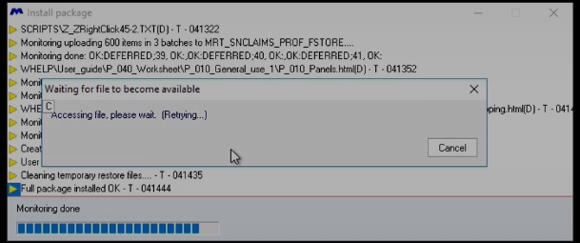
- After waiting for some time we will receive a pop up with patch where the backup is saved.
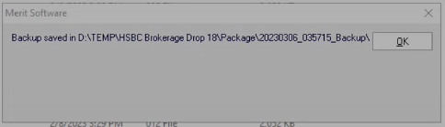
- Now click on and close the window and open the instructions provided by L3 engineering team in DROP release 18 package and Open the Thick client and do the Post release steps as follows.

Post Release Steps:
- Go to SETUP -> System parameters and click OK on the main dialog.
- Go to Users->Roles and click OK on the main dialog.
- Go to SETUP -> System parameters update base path for “Att.Ledger”
- Go to Static data-> System Options->Daily import scheme, Check and confirm below stages are enabled
- Import STATS data
- Import DISCOUNTS data
- Check If can run STATS
- Go to DB and run below query
- “select * from MRT_SNCLAIMSUPDPND WHERE MRT_CARDKEY like '%STATS_REDOSTAT%'”
- Run the below query if any row found in previous query.
- “DELETE from MRT_SNCLAIMSUPDPND WHERE MRT_CARDKEY like '%STATS_REDOSTAT%'”
- Follow the “Release instructions for the Web Site.docx” to setup the Web Front end

--------------------------------START- APPLICABLE ONLY FOR PRODUCTION DEPLOYMENT-----------------------------------
- Logon to the application server – 10.84.18.43 (if you are not already logged on to the server, go to Start->Run->mstsc and logon)
- Navigate to D:\Merit\
- Rename the INSTALL folder to rtd20210218@INSTALL
- Logon to the application server – 10.84.18.19
- Copy the folder : D:\Merit\INSTALL
- Paste the INSTALL folder in the Application server – 10.84.18.43
--------------------------------END- APPLICABLE ONLY FOR PRODUCTION DEPLOYMENT--------------------------------

- Now proceed with the release instructions for the web site as per instructions from L3 engineer in the call by looking into the document provided below.
- Now we are done with Thick Client part and now we need to follow the release instructions for web site as follows

Release instructions for the Web Site
Stop the “MERITMVC” and “MERITAPI” Web application in IIS
MVC project
- Stop the Web application with name “MERITMVC”
- Go to the web install location
for e.g. C:\MeritWeb\
- Rename the WebMVC folder to rtd20230213@WebMVC
- Copy the folder WebMVC from below location to C:\MeritWeb\
C:\merit\package\WebPackage
- Copy the web.config file from C:\MeritWeb\rtd20230213@WebMVC\ into
C:\MeritWeb\WebMVC\.
- Copy logo.png from rtd20230213@WebMVC\CMWEB\SETTINGS\MLPFINDER\APPSETCLAIM\ to WebMVC\CMWEB\SETTINGS\MLPFINDER\APPSETCLAIM\

API project
- Stop the Web application with name “MERITAPI”
- Go to the web install location
for e.g. C:\MeritWeb\
- Rename the WebAPI folder to rtd20230213@WebAPI
- Copy the folder WebAPI from below location to C:\MeritWeb\
C:\merit\package\WebPackage
- Copy the web.config file from C:\MeritWeb\ rtd20230213@WebAPI\ into
C:\MeritWeb\WebAPI\.

- Start the “MERITMVC” and “MERITAPI” Web application from IIS
- Click on the Application Pools, and right click on the MERITMVC in the right side then click Recycle
- Click on the Application Pools, and right click on the MeritAPI in the right side then click Recycle

- After the release have been completed for the web and for the application, try logging into the web and logout.
- Now we have to upload few patches in Thick client which were given in the Drop release 18 package, Login into thick Client and go to Setup – Local Implementation Script and a window will get opened as shown in below screenshot.

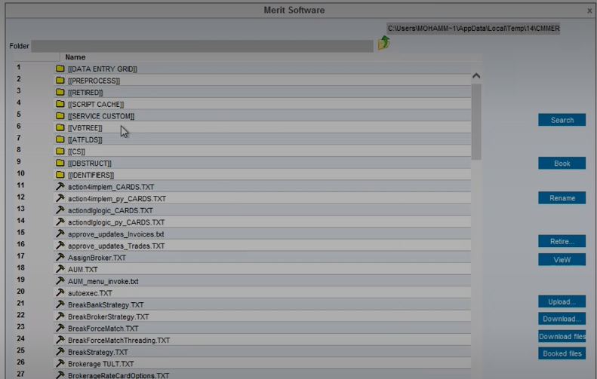
- Now go to VB Tree and download the TXT files suggested by L3 engineer in the call and take the backup in any one of the folder in your desktop.
- Now once the VB tree TXT file back up is done, open the patches folder from the Drop release 18 package as shown in below screenshot.

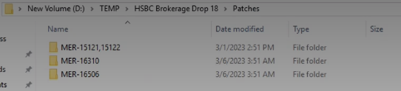

- Now we need to upload all these patches in Merit application by follow the below process screenshot.
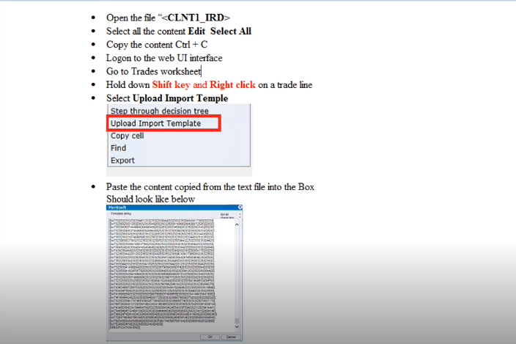
- Once all the related patches are uploaded in Merit application. Now upload the below patches in Thick Client.
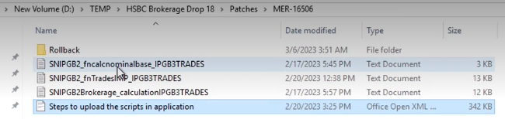

- To upload the patches, open thick client and follow the below process.

Steps to upload the script in application:
- 1.Open application click Setup -> Local(implementation) scripts
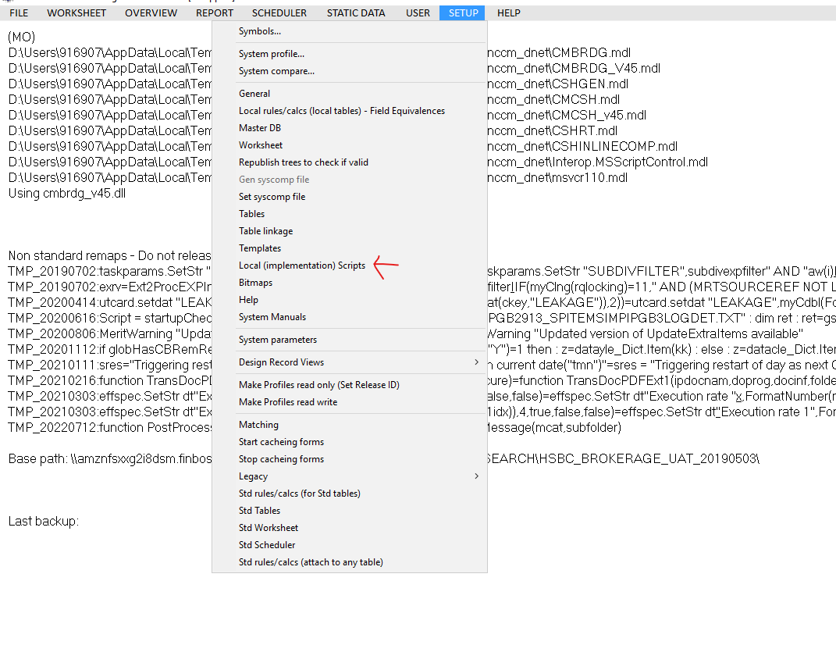
- 2. Click VBTREE

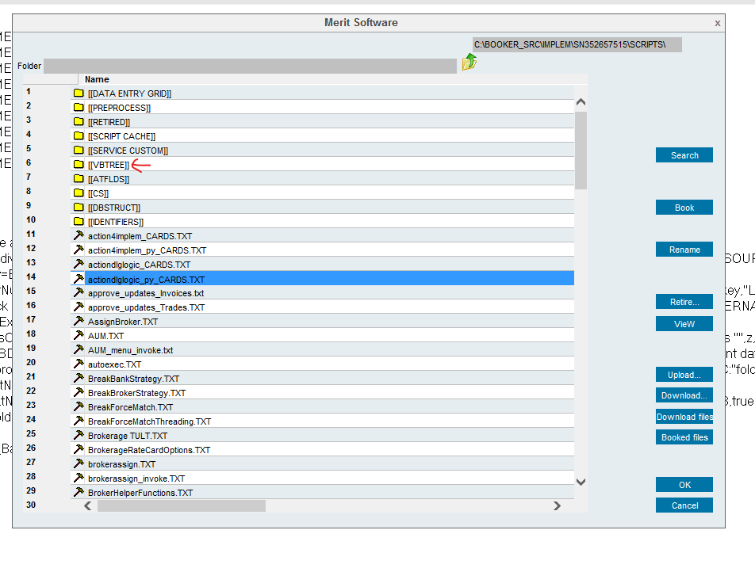
- 3.Retire the tree script that already existing like in the below image
For Example: [SNIPGB2913_SPITEMSIMPIPGB3LOGDET.TXT] This is the script name
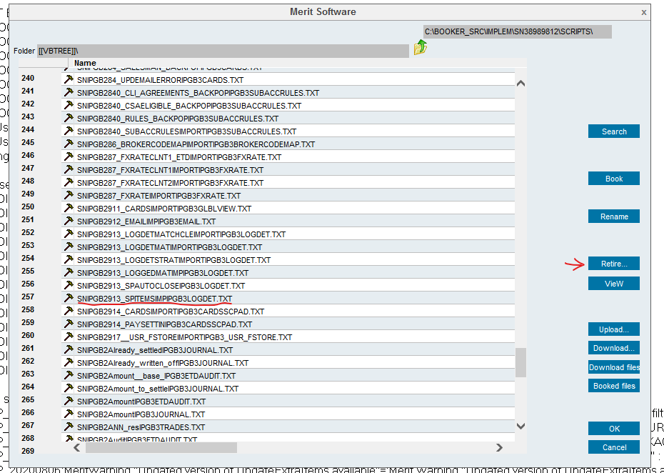
- 4.Go back using the symbol shown in the below image and click upload 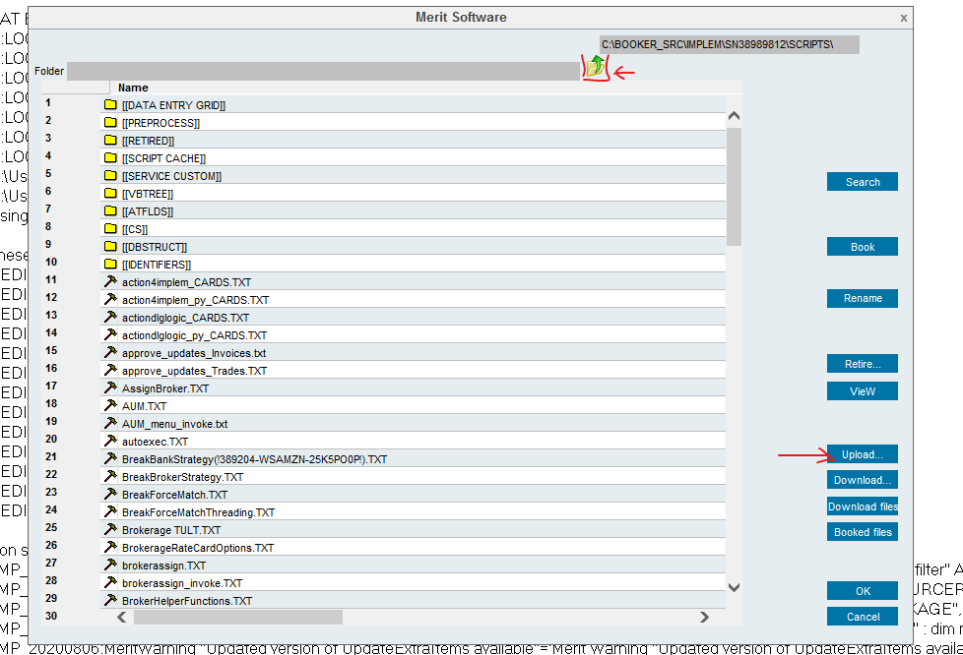
- 5.It will go to the file explorer click the script form the patch that you have downloaded and click open
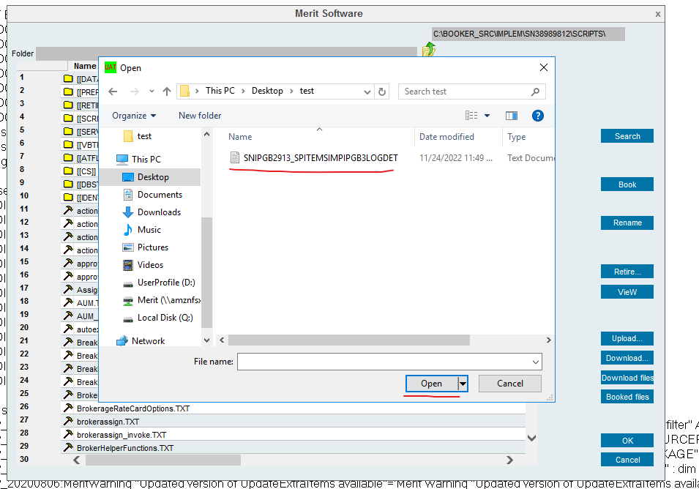
It will get upload.

- Once this patches upload is done in both merit applications and Thick Client. Now Start all the services which we have stopped as shown in below screenshot.

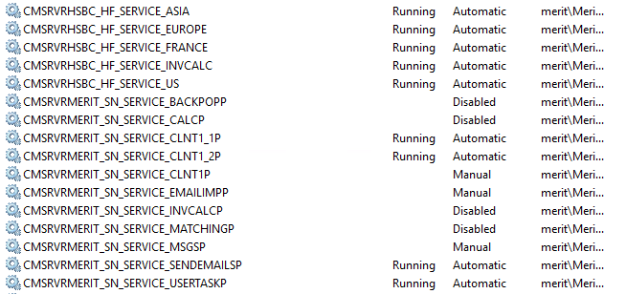

- We need to make sure that all the automatic services are up and running fine.
- If the Drop release is for UAT or Pre-Prod, Try to copy few ETD and OTC files atleast for 2 days from PROD and paste them in Data folder, before pasting the files in data folder stop the related services CLNT1_1 and CLNT1_2 and paste them and chage the cob date for these 2 services in thick client. Once pasted the files and changed the COBDATE start the services and observe if any of the service is erroring out and alanyse. This process is only for UAT and Pre-PROD and not for PROD.

- Now send an email to all the Ops team and other necessary participants saying that the Drop release has been completed successfully and so and so cob date files has been copied from PROD to UAT and Pre-PROD. Please l;et us know if any of the ETD or OTC files for a particular date needs to be copied from PROD to UAT and Pre-PROD as shown in below screenshot.

