Merit Application is Not Working/ Merit Slowness Issue

- When ever we receive an email from HSBC Ops team as shown below, that they are not able to access Merit application/Merit Slowness. We need to follow the below process.

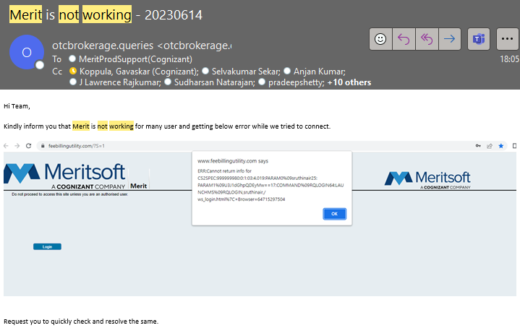

- If it is not mentioned as multiple users over issue reported email, send an email asking if multiple users or single user issue.

- If it is 1 or 2 users facing the issue, connect with them over teams and ask them to follow the below steps:
- Ask user to clear the cache from his system from setting advanced options
- Then request to restart his laptop or PC and ask them to login into the merit application
- Try to login from another browser in his machine
- Request them to check their Network connection

- If the issue is with multiple users, then follow the below process to fix the issue

- Update in the 48264 - Sev 2 - Merit Not Working 27 - April-2023 chat channel, so that the L3 and others who are already working on this issue will be aware.

- Open the Merit not working checks excel sheet and collect all the data from both 18.19 and 18.43 servers as shown below:
- CPU
- Memory
- Drive Space
- Check if any service is erroring out, if yes collect the logs
- Check the web logs, check the affected users connected to which server. Collect the web logs and web API trace logs from both servers (logs from 1 hour back issue reported)

- Now Login into both Production servers. Collect the CPU and Memory percentage from task manager as shown below screenshot
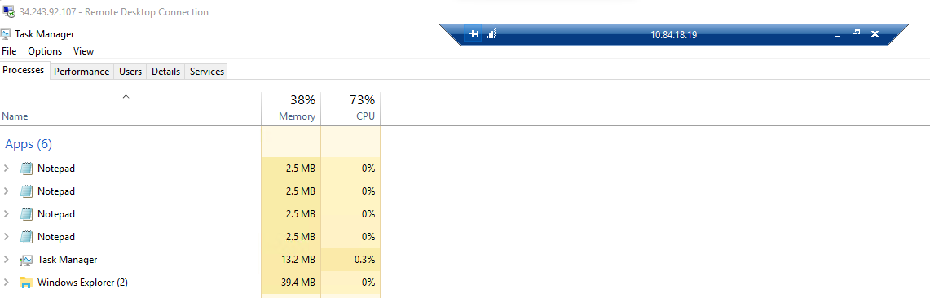

- Now check the Drive Space in both servers, if you fond any drive is full and red in colour. Try to delete the unwanted files from that drive.

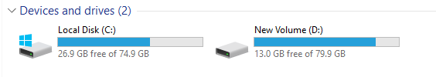

- Check the logs of all the automatic services in both servers and check if you have any errors. If you find any errors collected them in a Zip folder

- Now check the Web logs from both servers and try to find out the server that affected users and their team is connected

- collect the web logs and web API trace logs from both the production servers (Collect from past one hour of issue reported time)


- Collect the w3wp.exe thread count from task manager -> Details tab as shown in below screenshot

- Now enter all the details collected from both the servers in the Merit not responding check list excel

- Open IIS application from your search menu from both the servers and recycle only MERIT API in both servers.

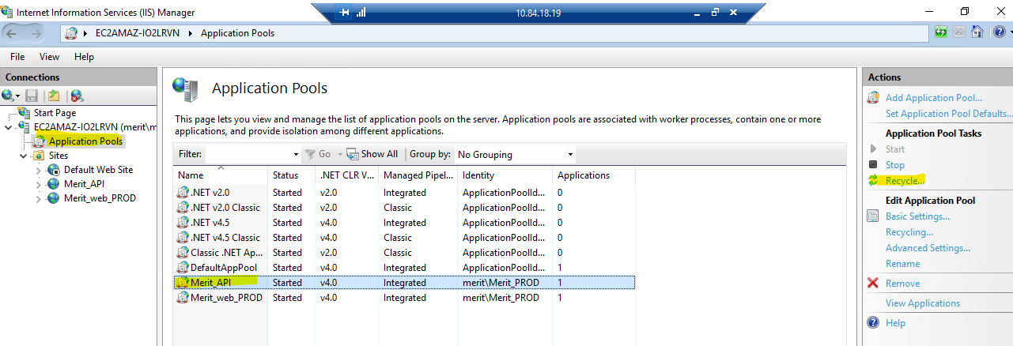

- Now open the Details tab from task manager again and collect the w3wp.exe thread count as shown in below
Note: Once we do Merit API recycle from IIS. We can see 3 w3wp.exe thread counts in details. But after some time, one thread will be disappeared
- Now send an email to Ops team that we have did Merit Api recycle in both servers and request them to access Merit application and check if it is working and all the affected users are able to do their day-to-day activities.

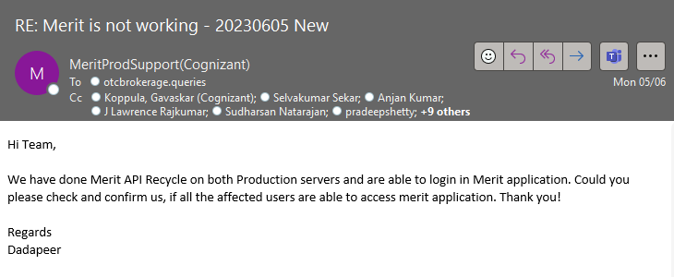

- Open Jira parent ticket https://cognizantproducts.atlassian.net/browse/MER-14061 and update all the details, logs and screenshots collected in both servers and update in the Merit not working teams chat channel that all the logs and screenshots are updated in Jira – 14061

- Now open performance monitor in both prod servers, Performance Monitor->Data collector set->user defined ->May 22 – 18.19 -> right click and stop it.

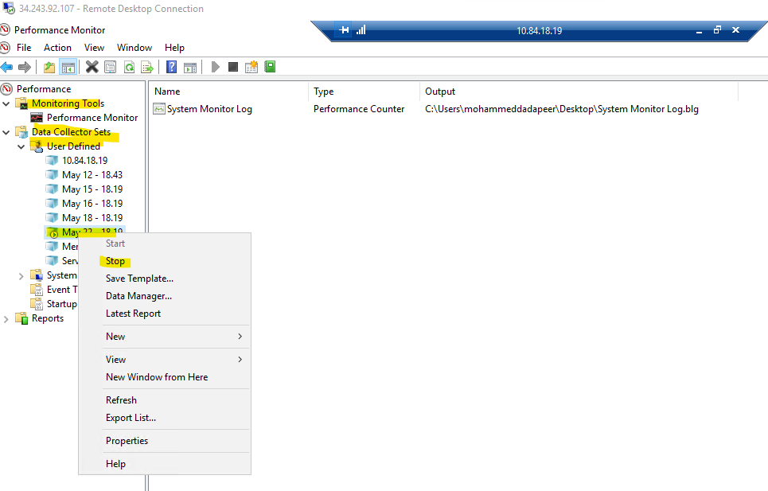

- Go to C-Drive, Users, Mohammed Dadapeer, Desktop and copy the Performance monitor logs data

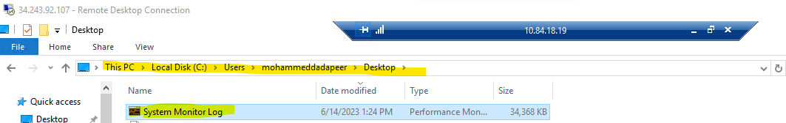

- Now paste the performance monitor data file in Jump server C-Drive Temp folder by naming the file with today’s date and server number as shown in below figure.

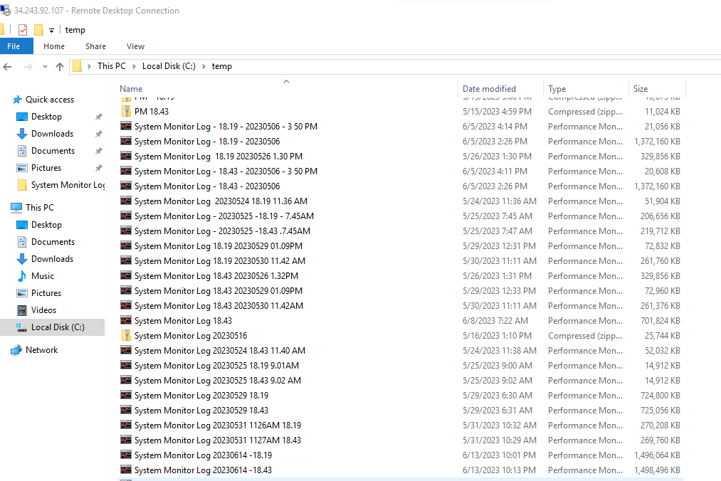

- Update in Jira 14061 and Merit not working chat channel that we have pasted the performance monitor data logs in Jump server and paste the path.

- Now again go to C-Drive, Users, Mohammed Dadapeer, Desktop and delete the performance monitor data file

- Open performance monitor, Data collector sets, User defined and right click on May 22 – 18.19 and click on start option as shown in below figure.

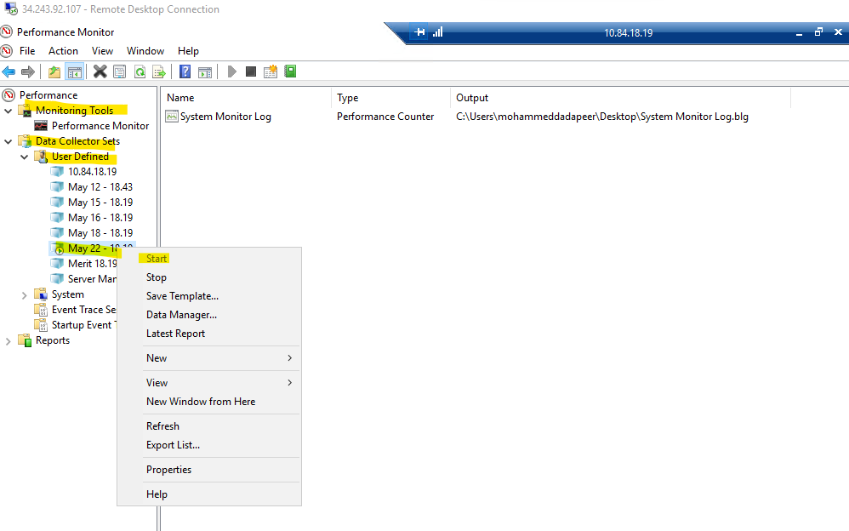

- Now check with user over an email and get confirmation if the Merit application is working fine and close the case.

