Rebuilding Indexes in SQL PROD

Whenever Max or Engineering team send an email or requests Support team to perform rebuild indexes in SQL in PROD server 18.19. We need to follow the below process.

- Login into HSBC server production server - 10.84.18.19 through Jump server.
- Click on search and type SQL and open SQL Management and enter the below in the server name tab

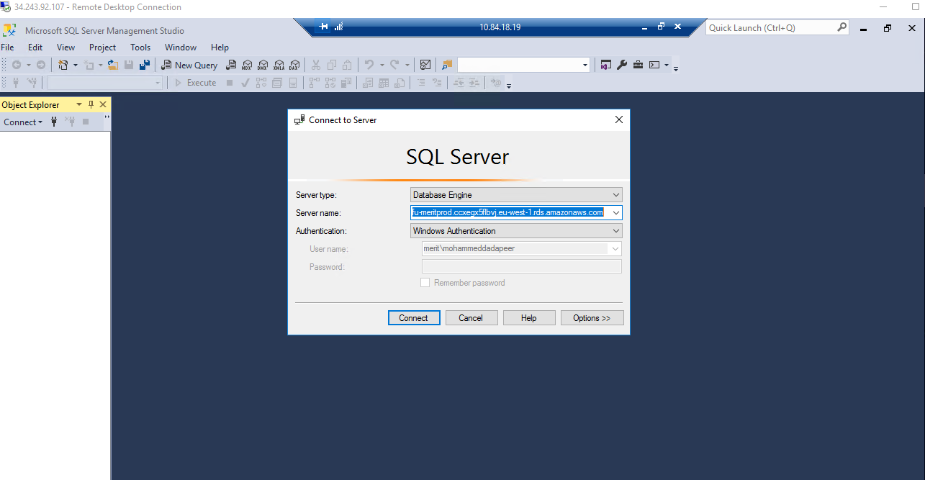

- Once we click on connect, we need to click on Databases->Merit PRDO->Tables->dbo.MRT_SNCLAIMSTrades->Indexes

- In dbo.MRT_SNCLAIMSTrades table in Indexes tab right click and chose Rebuild all

- Once we click on rebuild Index, a window will be populated as below now take the screenshots as shown below.

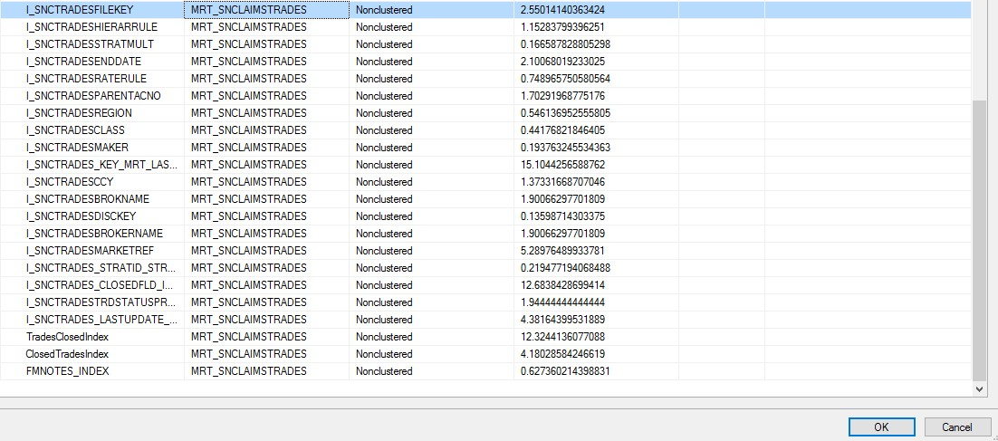

- After taking Screenshots, Click cancel

- Again, go back to Databases->Merit PRDO->Tables->dbo.MRT_SNCLAIMSLogdet->Indexes

- In dbo.MRT_SNCLAIMSLogdet table in Indexes tab right click and chose Rebuild all

- Once we click on rebuild Index, a window will be populated as below now take the screenshots as shown below.

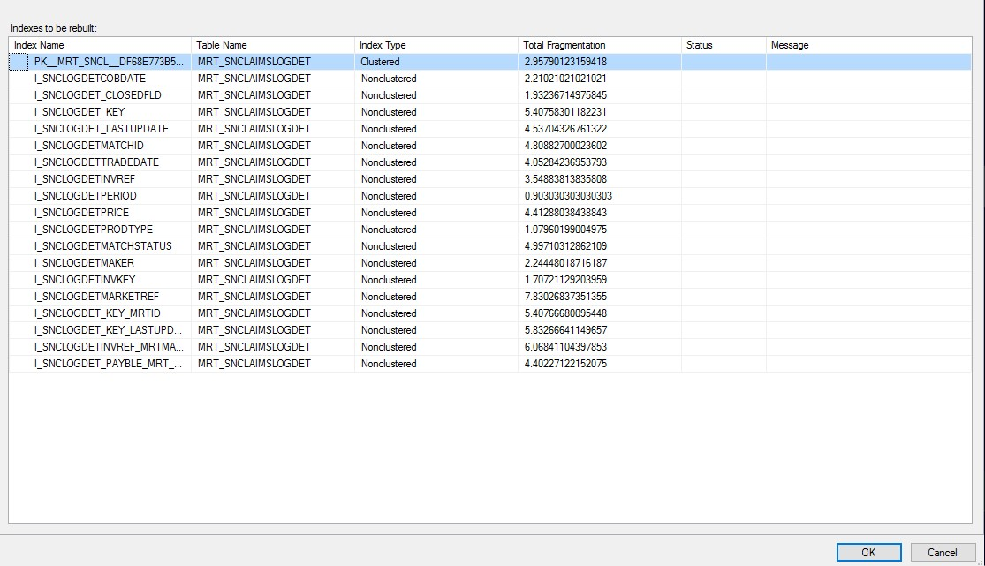

- After taking Screenshots, Click cancel

- Now Click on new session in SQL -> Merit PROD write the below query and execute it and take the screenshot as you have started it. As shown below

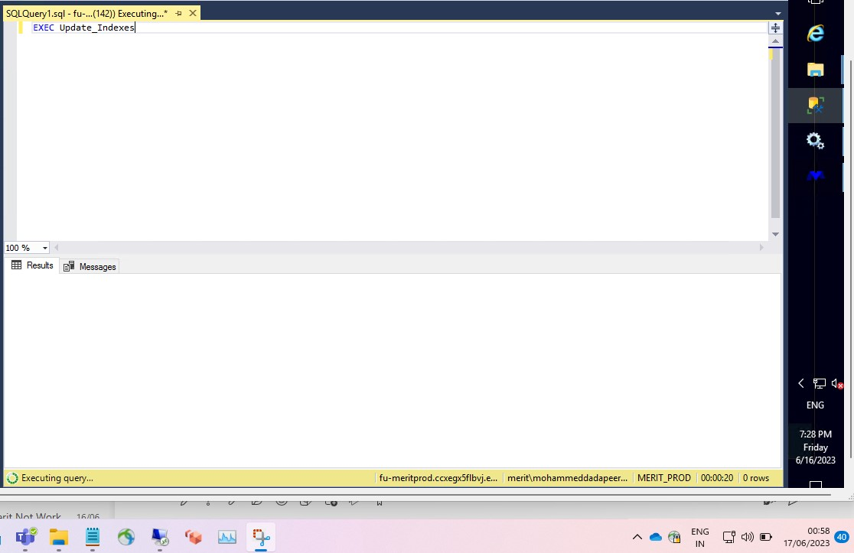

- This query will take 3hours + time to run and show us the message. Once this query is completed take the screenshot as shown below.

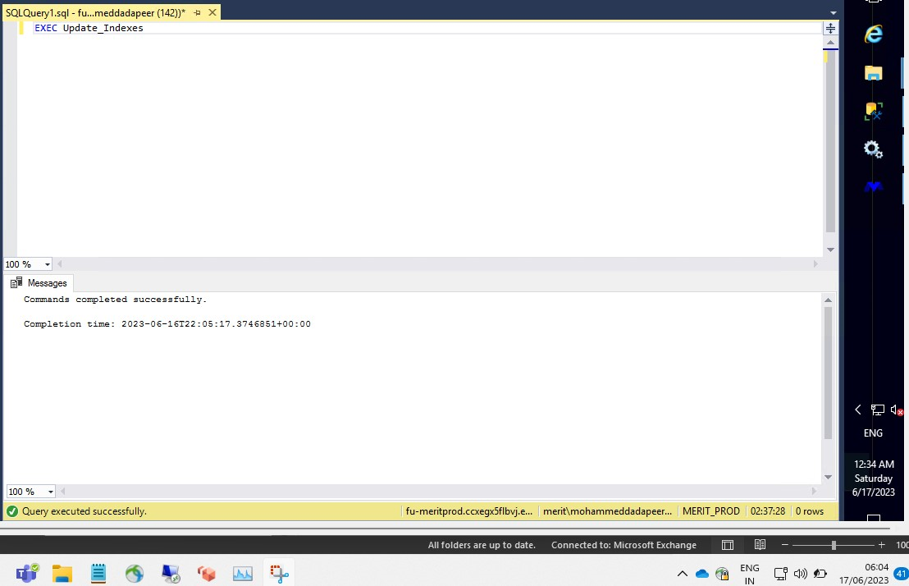

- Now again go to Databases->Merit PRDO->Tables->dbo.MRT_SNCLAIMSTrades->Indexes

- In dbo.MRT_SNCLAIMSTrades table in Indexes tab right click and chose Rebuild all

- Once we click on rebuild Index, a window will be populated as below now take the screenshots as shown below.

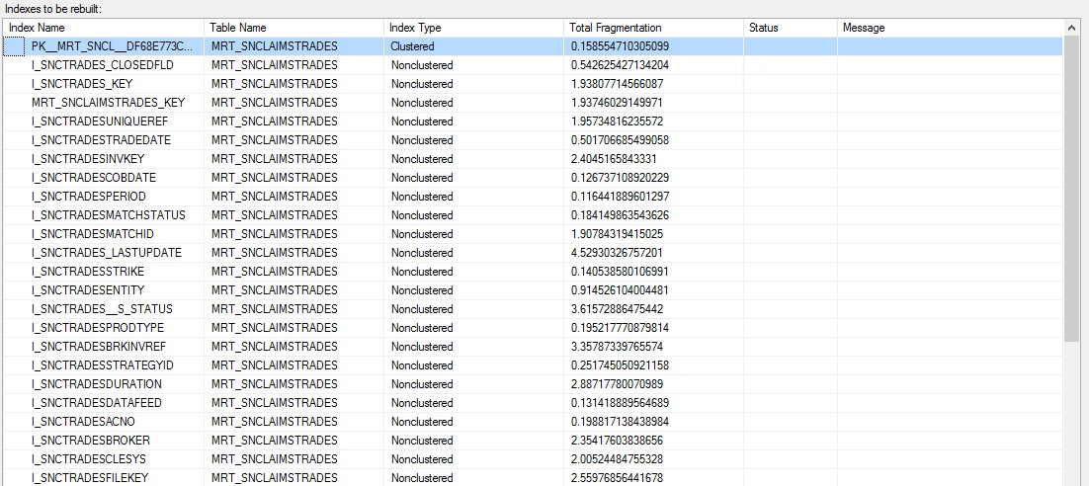

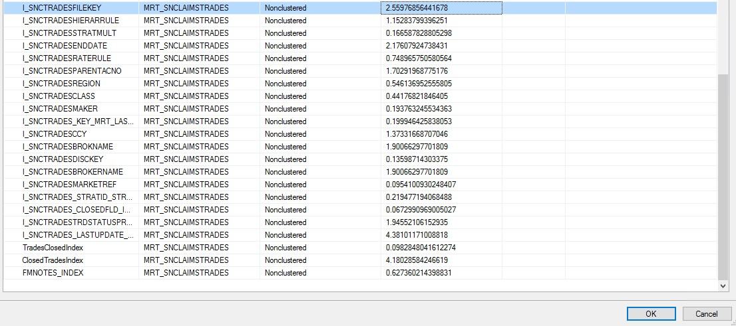

- After taking Screenshots, Click cancel

- Again, go back to Databases->Merit PRDO->Tables->dbo.MRT_SNCLAIMSLogdet->Indexes

- In dbo.MRT_SNCLAIMSLogdet table in Indexes tab right click and chose Rebuild all

- Once we click on rebuild Index, a window will be populated as below now take the screenshots as shown below.

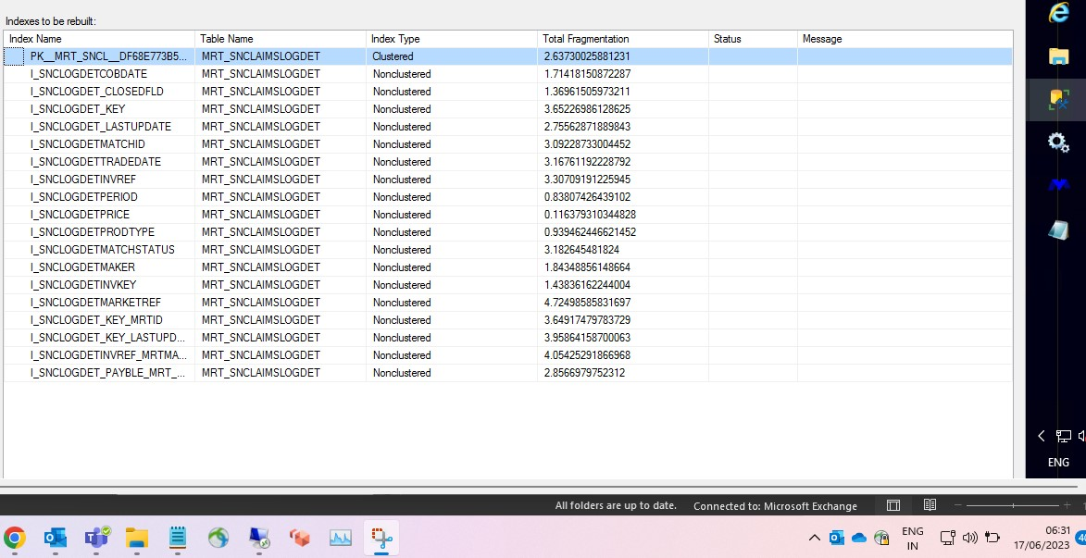

- After taking Screenshots, Click cancel

- Now the rebuilding indexes for MRT_SNCLAIMSTRADES and MRT_SNCLAIMSLOGDET is completed

- Now send an email to the requested person or team by looping Gavaskar, John and Merit PROD Support team.

