Request to Break Match the Trades

Break Match:
Brokerage Operations team may encounter trades matched to incorrect instructions or affected by key lock errors, as well as trades appearing in incorrect statuses like USRMATPC or others instead of their actual state. In such scenarios, the Operations team will request the Support team to perform a break match from the backend using SQL, enabling them to proceed with their activities in Merit.

- Whenever support team receives an email request from Ops team to Break Match the match ID’s as shown in below screenshot. We need to follow the below defined process.

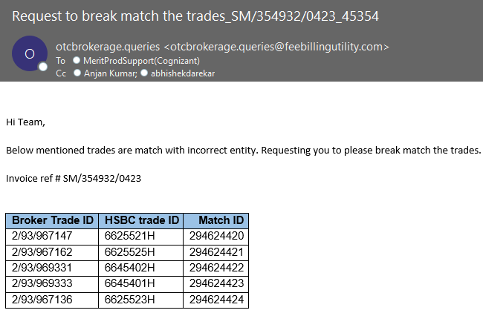

- We need to check the below necessary steps before doing the break Match in any environment.
- Check if user has provided the appropriate reason for doing the break match. If not request user to help us with the proper reason for doing the break match
- Check if the user has taken approval from his manager for doing the break match. If not, request user to get an approval for doing the break match
- Check if user has provided the Match ID’s for doing break match
- Check with user if its urgent request to break match (Only Month ends). If yes do the break match after having the above the 3 steps. If not urgent, wait for 1 business day and check with user if the issue persists or resolved.
- If user has provided the above requested details (Proper reason, Manager Approval and Match Id) and confirmed it is urgent or if the Match Id’s are not auto break matched after 1 business day, then follow the below process for break matching.
- Now move the user email to the Production server (10.84.18.19 or 10.84.18.43) through accessing your web mailbox from Jump server.
- Once login into Production server, access Merit application in browser through the below link and credentials.

- Https://localhost/
- ID: Adminweb, Adminweb1, Administrator and Administrator1
- Password: sunshine1

- After logging into the Merit application, go to Broker: HouseTrades tab and click on search and give the below Criteria and click on search as shown in below screenshot.

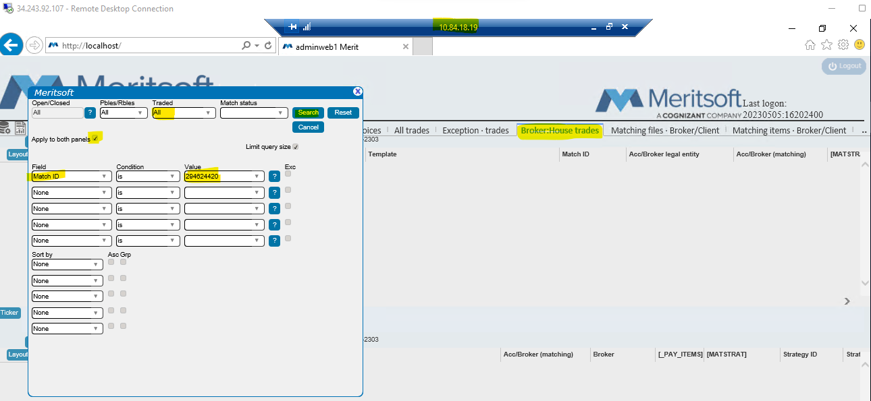

- After clicking on search button, we will see the trade for which we need to do break matching as shown in below screenshot

- If user has provided multiple match Id’s for break matching, In the search criteria – Value Tab enter the other match Id’s By giving Coma (,) and follow the same process as shown in below screenshot.

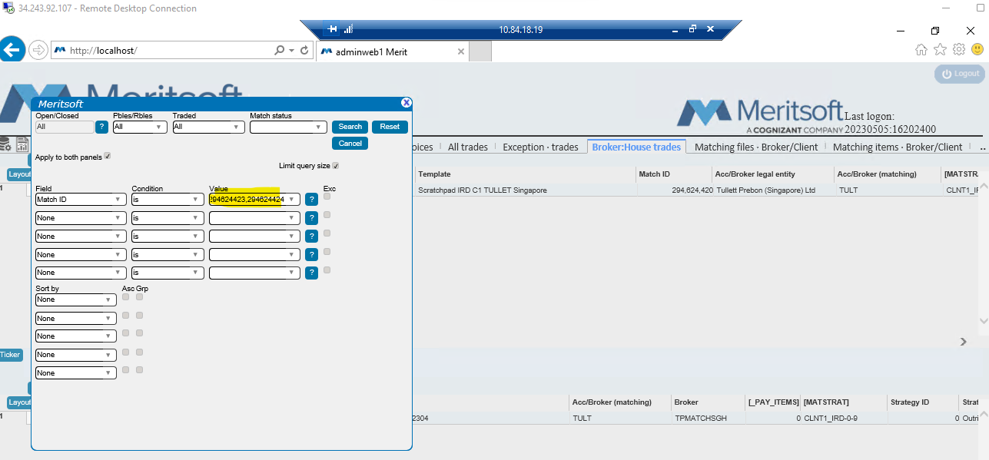

- Once we click on search Button, we can see all the match Id’s provided by user in both Bank side and Broker side as shown in below screenshot.

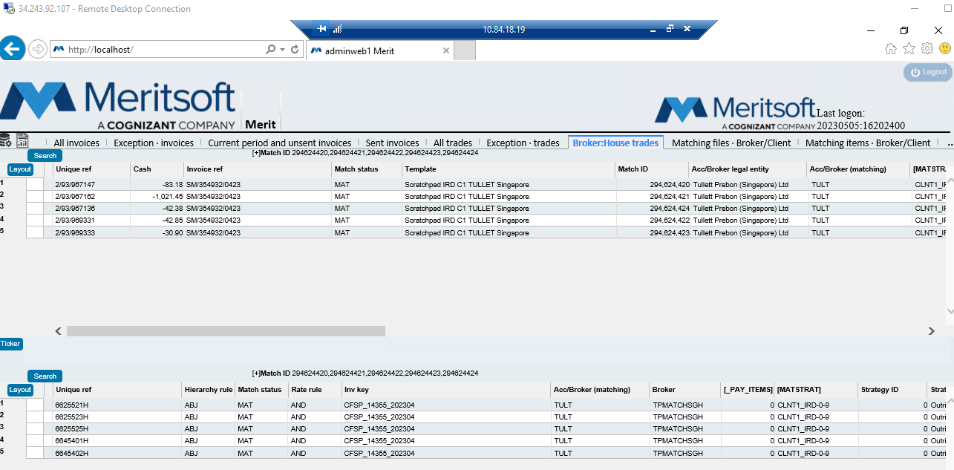

- After clicking on search button after 1 business day, if you don’t find any trades in both bank and broker side. Check with user if the issue is resolved or persist
- If user confirms, issue is resolved close the ticket by taking user confirmation. If not reach out to L3 Engineering team to check the issue.

Note: In most of the scenarios after waiting for 1 Business Day during Month ends the issue may get auto resolved. As per the update from L3 team below are few scenarios:
- Invoice ref has not been Stamped
- Could not find trade in Counter party side
- Trade is in USRMATPC
- Trade is in MAT status

- If the user confirms, the request is urgent due to month end and they cannot wait, then we have do the break match the requested match ID in SQL Database in appropriate environment servers
- For doing break match we need to login into SQL database and write a query as shown in below Screenshot.

- We have to right the above break match query, in a new query. In the query we need to give the match ID which is provided by user, and we need to break match it by clicking on Execute option below new query in SQL database.
- Once we click on execute option, we will see 1 row affected pop up in the SQL data base in the bottom side, if there are multiple match Id’s in the query, we will get that many rows affected in the bottom side if SQL Database.
- That means the query has been executed and the break match has been completed for the requested match Id’s
- Now Open Merit application again and cross check the match Id’s provided by user. If the break match has been done in SQL database, then the trades has to be blank in Merit application as shown in below Screenshot

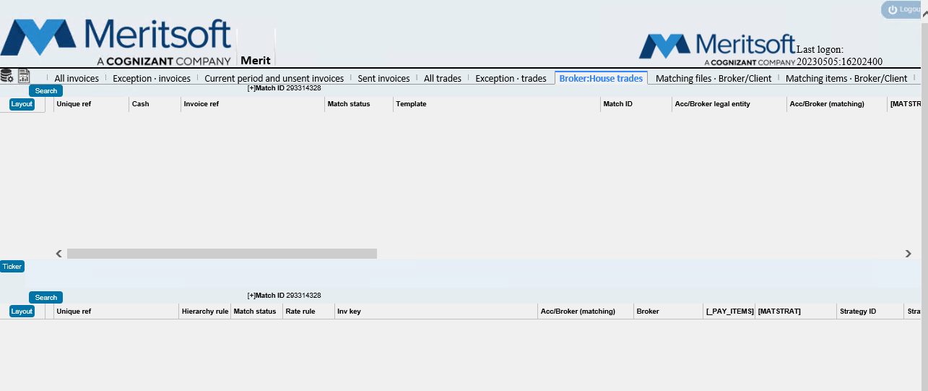

- Now Inform user that the break match has been done for the requested match Id’s and request them to check and confirm from their side.
- If user confirms that the break match looks fine from his side, close the ticket
- If user confirms that the break match has been not reflecting in his merit side, then ask them to do re-trigger in his merit application.
- If the issue is not resolved after doing break match and re-trigger, then reach out to L3 engineering team and inform them the steps followed and try to fix the issue ASAP.

