Request to check AWM Trades
- Whenever support team receives an email from otcbrokerage.queries, Request to check AWM trades as shown in below figure.
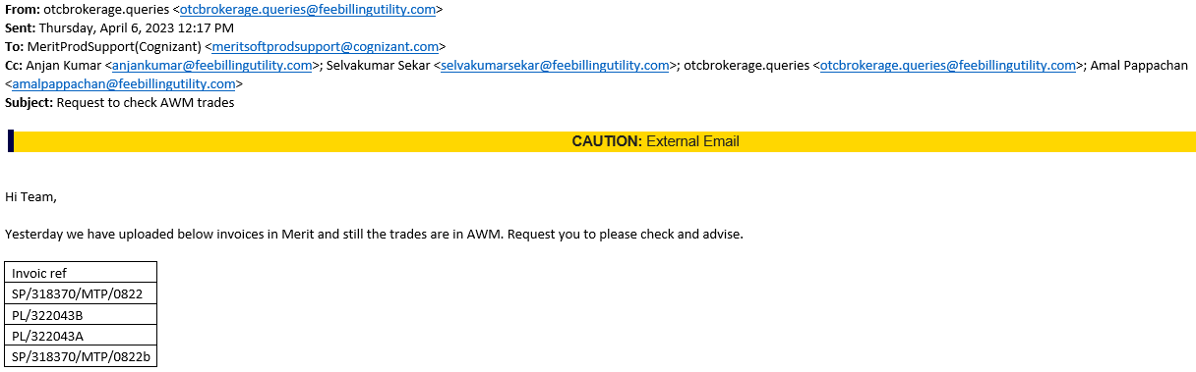
- Support team has to move this email in which user has shared the keys which got struck in AWM status as follows.
- Login in to Jump Server (34.243.92.107) and Login in to the any one of the Production Servers 10.84.18.19 or 10.84.18.43
- Now check the all the merit services like INVCALC, MATCHING, BACKPOP, CLNT1_1, CLNT1_2, CALC, USERTASK, SEND EMAILS etc.
- If any one of the services is erroring out in logs react out to L3 Engineering team and inform them and fix the service erroring out issue ASAP. Because this might be one of the reasons to struck the keys provided by user in AWM status.
- If you don’t find any of the service erroring out in both Production servers. Then login into Meritsoft mailbox and copy the Invoice refs provided by user in the email as shown below.
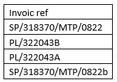
- Now login into Merit application and go to matching items tab and search for the Invoice reference provided by the user as shown in below screenshot.

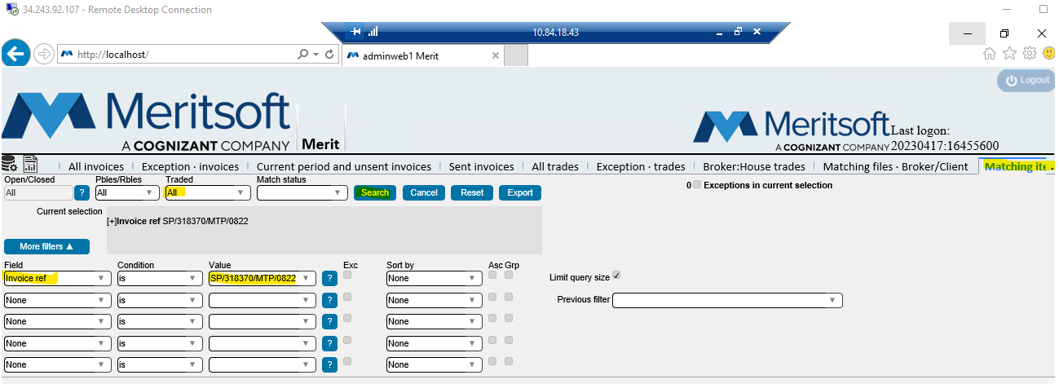
- Once click on search, we can see the trades and in that we need to see the match status, then we need to if the status AWM as shown in the below screen shot
- Login into Microsoft SQL Server Management Studio 18, by searching in start, as shown in below Screenshot

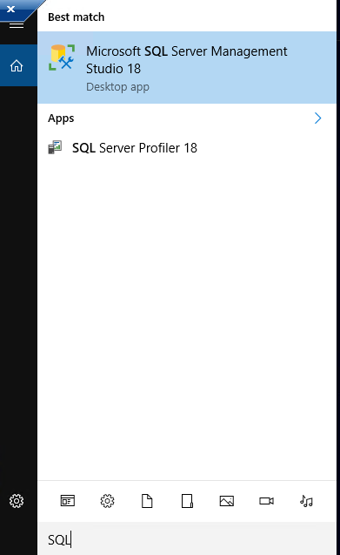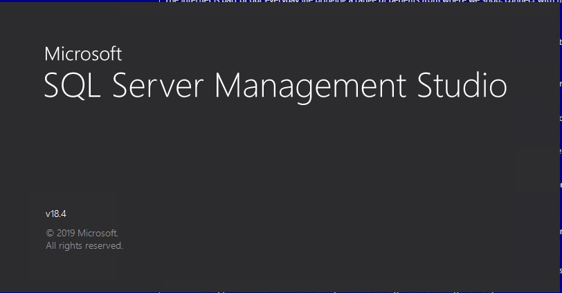

- Login into the SQL with the below Credentials and make sure to choose Merit PROD and New Query as shown in below screenshots

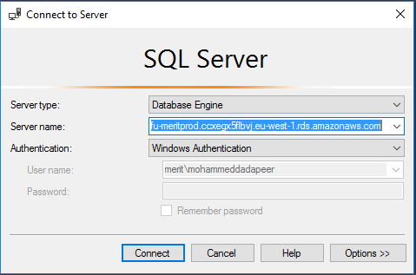

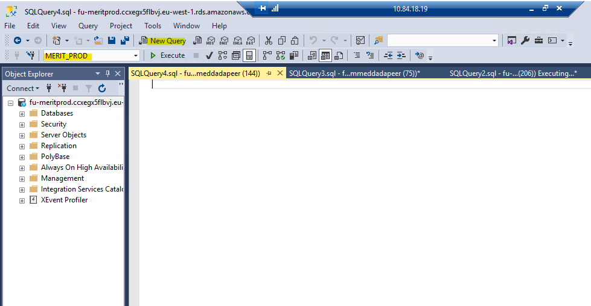

- Now Paste the Query which was requested by Dev team as shown in below screenshot and execute it by giving the Match by status of the invoice number as shown below

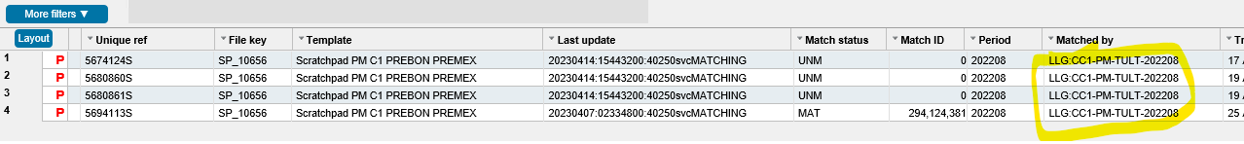

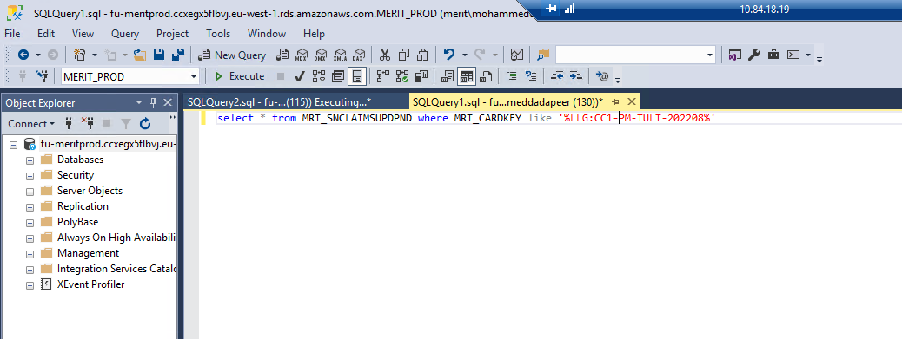

- In the query result, if you find the user requested key value, then inform user that it is in progress and it will get completed shortly as you can see it in results.
- Incase if you did not find any match by Key in the query result, now go to the merit website again and right click on the matched by Key of the invoice number and click on Retrigger match as shown in below screenshot
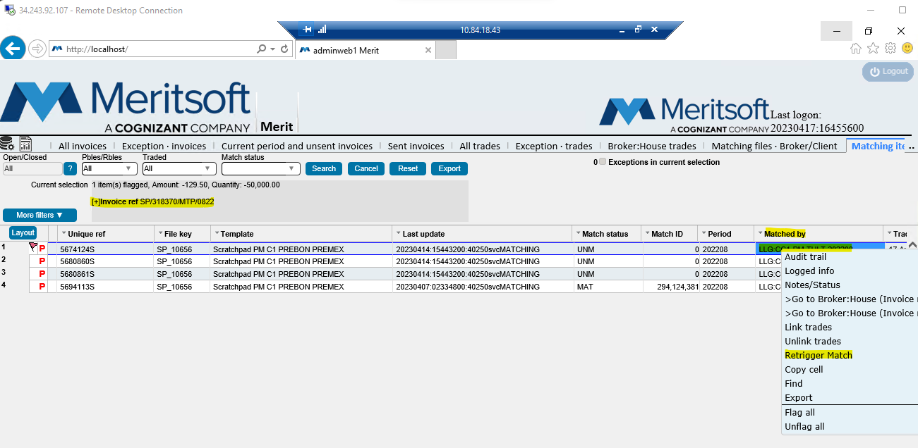

- After clicking on the retrigger match, now go to the SQL data base and again run the query. now you find the matched by Key of the invoice number in the result.
- Now go to the matching logs and open the latest log and search for the matched Key for which we have did retrigger match, if you find it inform user that we have retriggered the matched by key of the provided invoice ref which is in AWM status.
- If you don’t find matched by key of the provided invoice ref in SQL data base extract and matchings logs. Please reach out to L3 Engineering team.

NOTE: As per update from L3 Engineering team this type of AWM trades issues we will see in the month end activities performed by ops team.
- After retriggering matched by wait for some time and check the match status, it should be anything other that AWM. If you find it same AWM, please reach out to L3 engineering team.

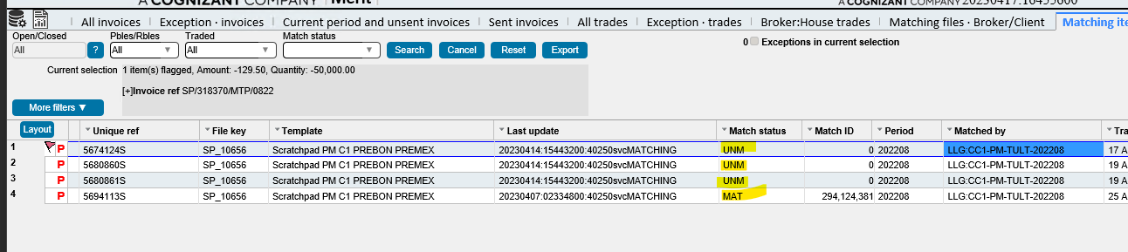
- Once the match status changes from AWM to other status. Inform user to check and confirm. Once user confirms please proceed to close the ticket.

