Scratchpad Amendment or Missing Sub Product Request

- When ever Support team receives Scratchpad amendment or Missing Sub Product request from user. We need to open the request in Zendesk and triage it as Task, Low, HSBC, Brokerage Production and keep the ticket in L2 queue in Open state as below.
Refer - https://cognizantproducts.zendesk.com/agent/tickets/44573
- Firstly, we need to check and understand what exactly user wants us to update in the existing Scratchpad. Also we need to check the invoice attachment in the user request, if the invoice is missing request user to share the Invoice excel. If the excel is in word or PDF format, request user to share it in Excel format.
- If the requirement and attachment are correct in the ticket, Support team must create a Jira ticket in Jira application as below.
Refer - https://cognizantproducts.atlassian.net/browse/MER-16087
- Once we create Jira ticket in Jira application, we need to map the Jira ticket number in the Zendesk ticket in Related Jira tab.
- Now, we have login into Azure Workspace to Amend the existing Scratchpad as below.
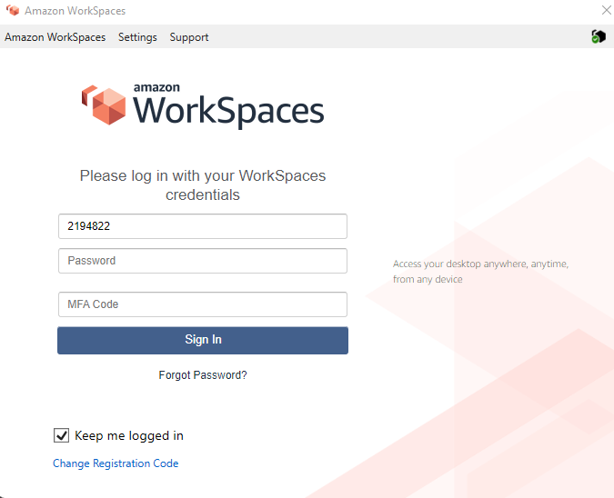

- For logging into AWS, we have to give username as our Cognizant Employ ID, AWS password and Okta verification 6 digits code and click on sign in.
- Once we login into AWS, we will be in a different instance, as shown below.

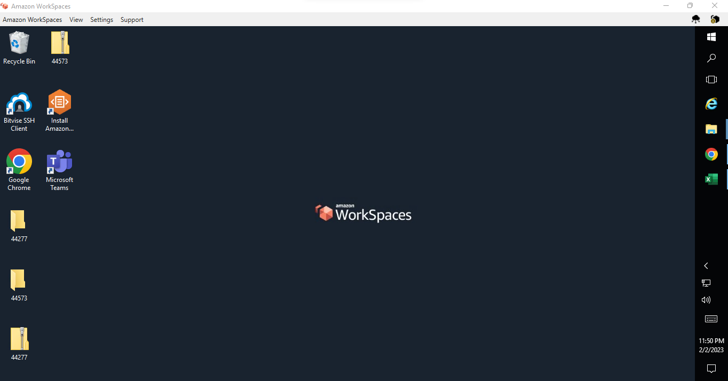
- Now, we have access Web email or Teams in AWS and download the invoice excel provided by requester.
- We have to access Merit application in chrome using IP address – 10.104.1.159:22030/?S=1 as shown below

Login ID – Adminwebgvk
Password – sunshine@1

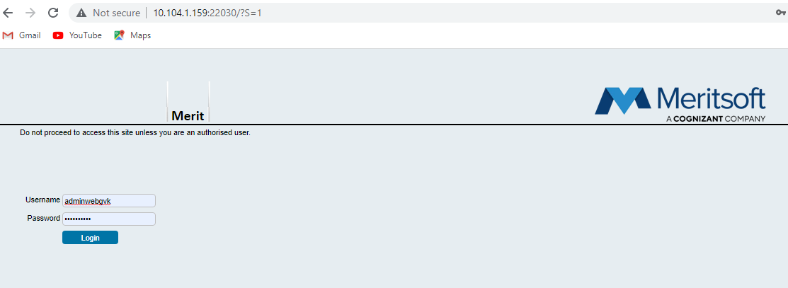
- Now we need to login and go into Emails Tab, right click and choose Upload Data as shown in below screenshot.

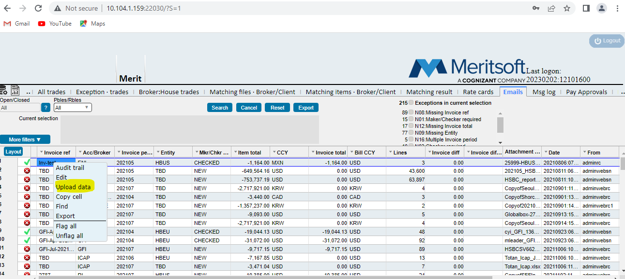
- After clicking upload data a window gets populated as below, Now enter the Scratchpad name and click on Ok as shown below

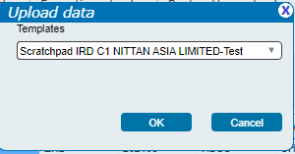
- After clicking OK, a window populates as below asking to browse and upload a file. Now we have to upload the file which we have downloaded (Provided by requester)

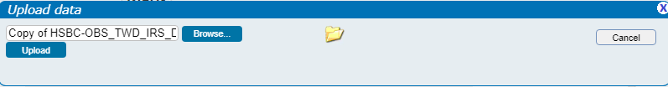

- After uploading the invoice excel provided by requester, a window gets populated showing the invoice excel as it is in Merit application as shown below.

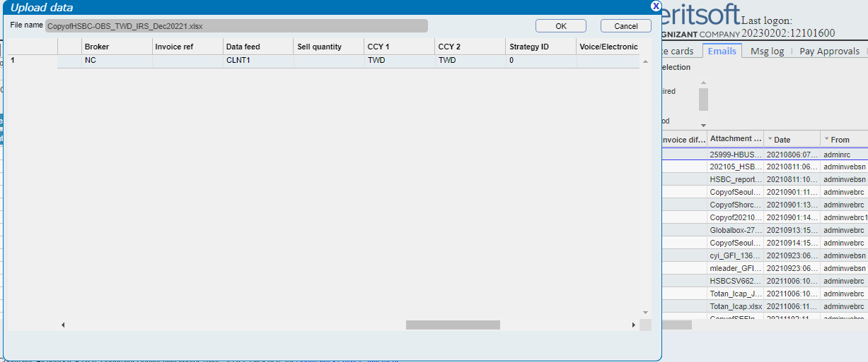
- Now we have cross check in this merit application invoice, what exactly we have to change as per user’s request.
- Now we have to login in to Thickclient application by using the below path.

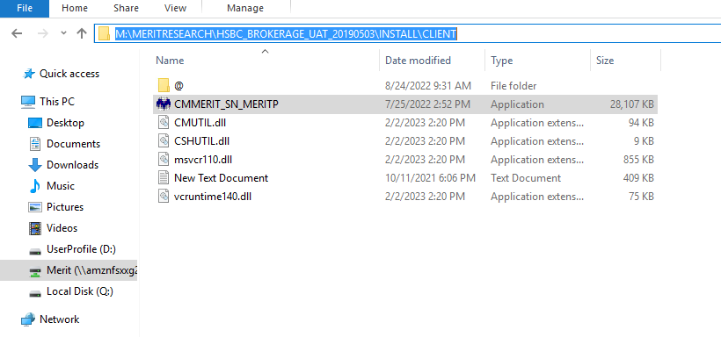
- After double clicking on the Thickclient application, login window populates, use the below credentials for logging in.

Login ID – Adminrc
Password – sunshine1

Note: Once we give credentials and login into Thickclient, A window gets populates, click on Run, also few more windows will get populates as below, we can cancel them by clicking Shift+Cancel as shown below.

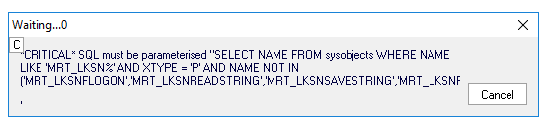
- Now, click OK, when the below window populates.

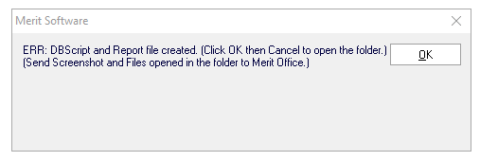
- Now, click shift cancel, when the below window populates.
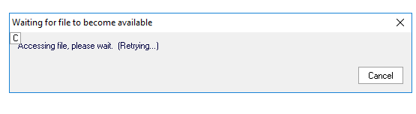

- Once we click on Thick Client, it looks like as shown in below Screenshot.
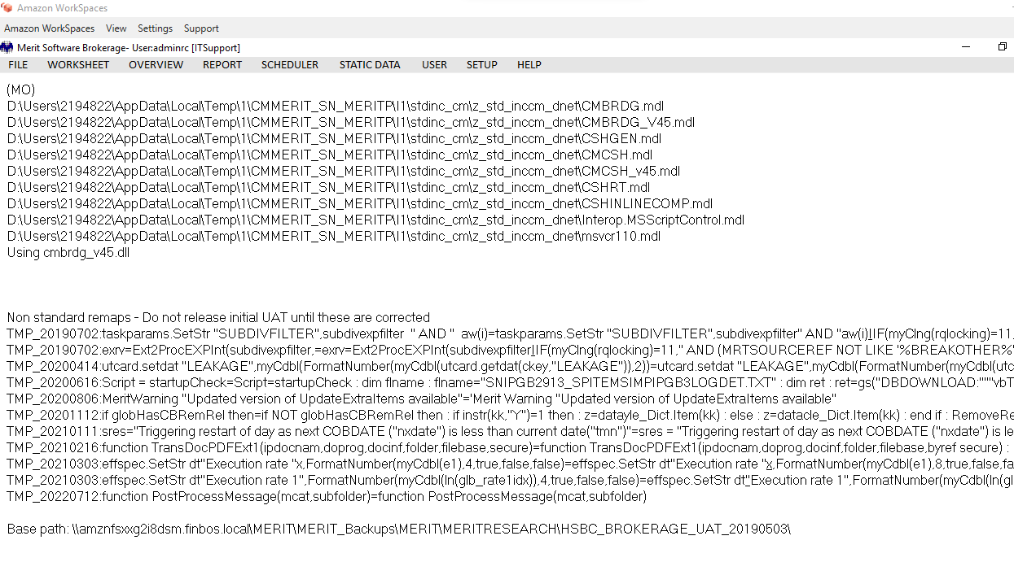
- Once we login into the thick client, we need to go Static Data – System Options – Import Templates and try to find out the Scratchpad name provided by requester in the ticket (Scratchpad IRD C1 NITTAN ASIA LIMITED)
- Once you find out the scratchpad in the import templates, right click on the Scratchpad and copy it. This is because, we must take roll back of scratchpad before we do any sort of modifications in it. As shown in the below screenshot.
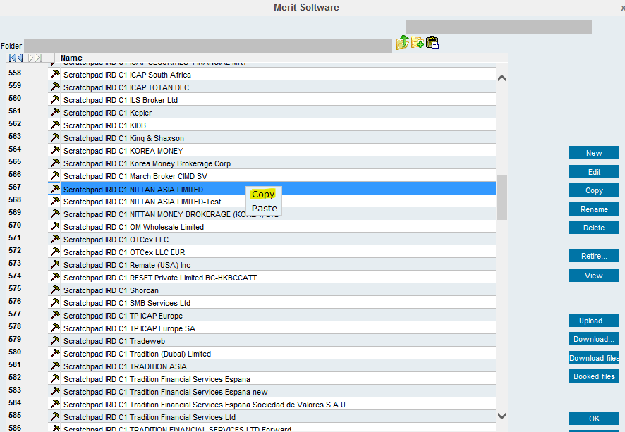
- Once we click on Copy, it will copy to a clip board and we need to paste it in a notepad and save it as rollback for the appropriate Scratchpad.
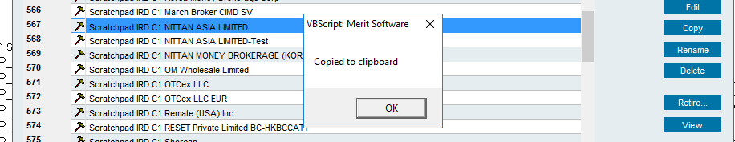
- Now Create a new folder in AWS Desktop with the ticket ID and create another folder inside as Roll back and inside roll back folder create a notepad and paste the roll back in it.
- Also whether it is a new Scratchpad or modification to an existing Scratchpad, we need to provide Scratchpad patch update instructions to user and also create a new note pad to provide a new patch user as shown in below screenshot.

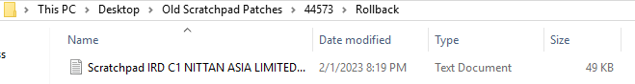

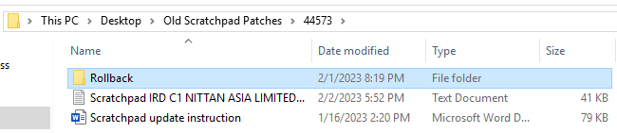
- Now take the copy of the Scratchpad as shown in the below screenshot and rename it as rtd20230411Dadapeer@ Scratchpad IRD C1 NITTAN ASIA LIMITED and click ok. A copy of that Scratch pad will be created, and the old Scratchpad will be retired.
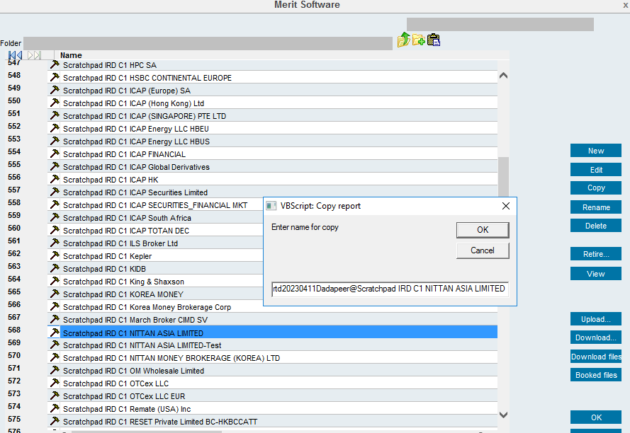

- Once the folder is created and rollback has been taken, now again go to thick client – scheduler – Static – Rebrowse data in Import template – Edit as shown below.
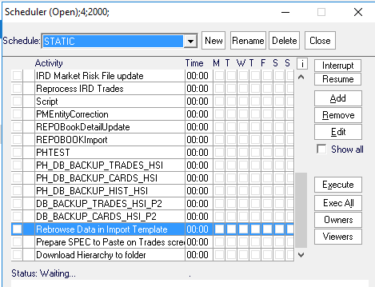
- Once we click on edit a script will be opened as shown below now, now edit the scratchpad name there given by requester in scratchpad.
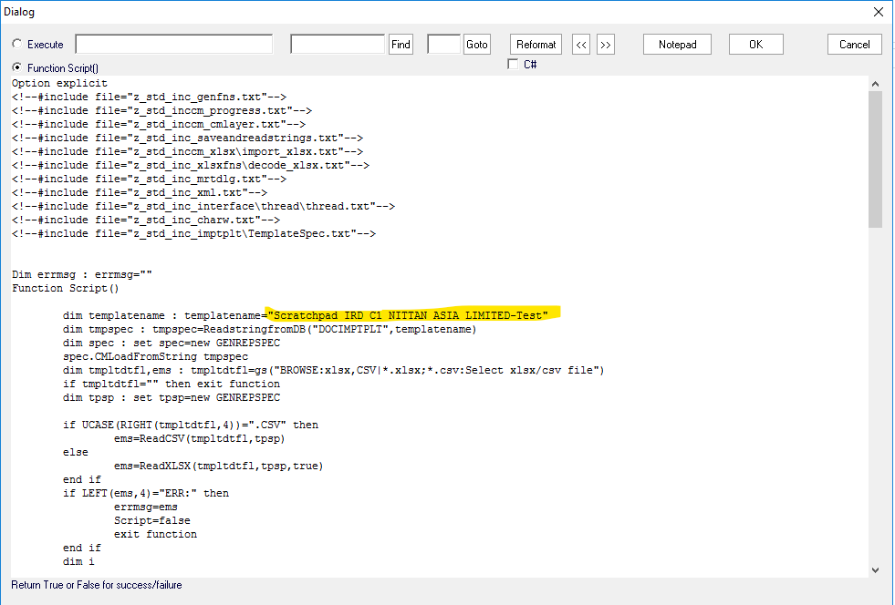
- Now click ok on top right and execute the script as shown below.
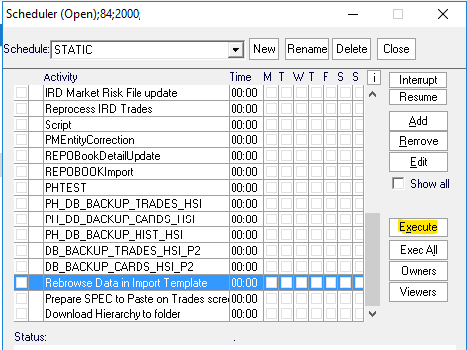
- Once we click on execute, a window will get populate and ask for a invoice excel. Choose the invoice excel provided by user and click on open.
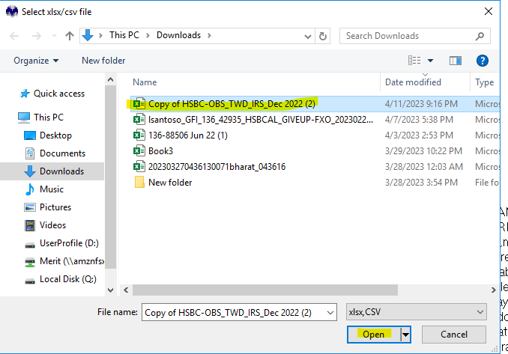
- Once we click on open a window will be open as shown below, now try to find out what exactly user has requested us to modify in the existing scratchpad.
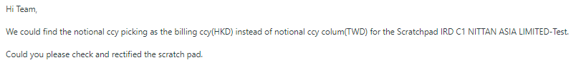
- As per user request he has observed that notional CCY is picking as billing CCY instead of notional ccy column for the scratchpad.
- Once we Rebrowse the scratchpad it looks as below.
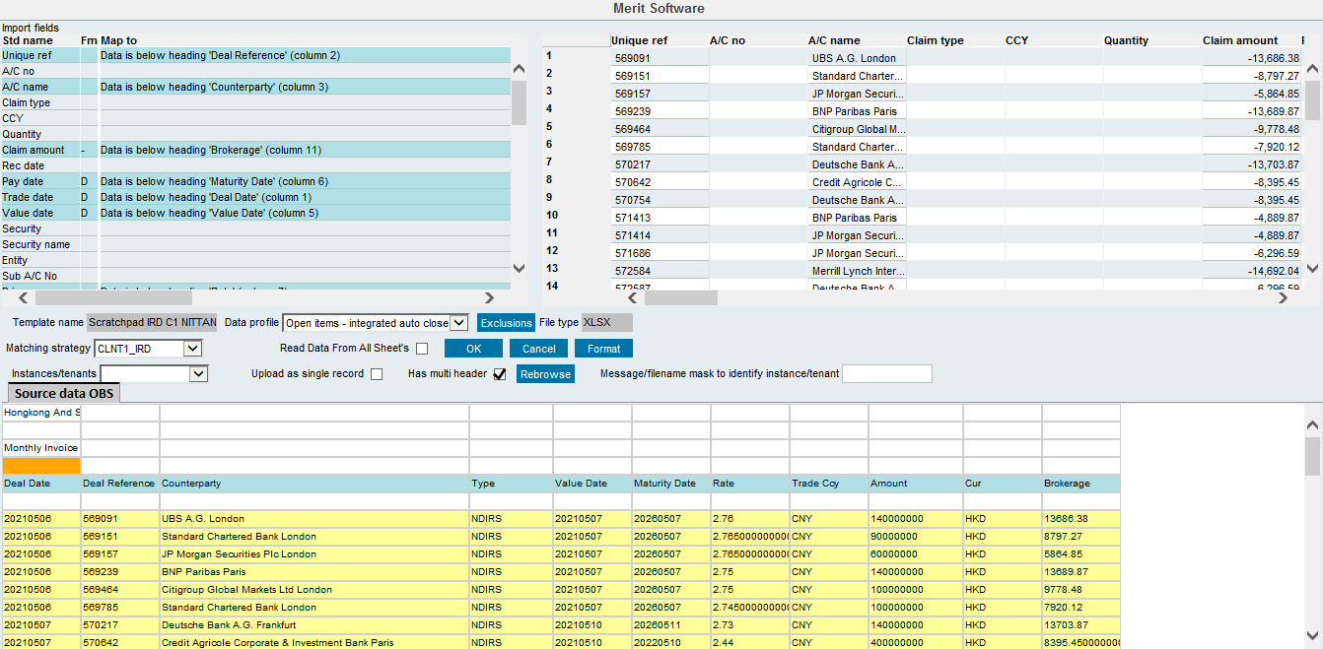
- As per users request, we have made changes as below by giving a formula as below
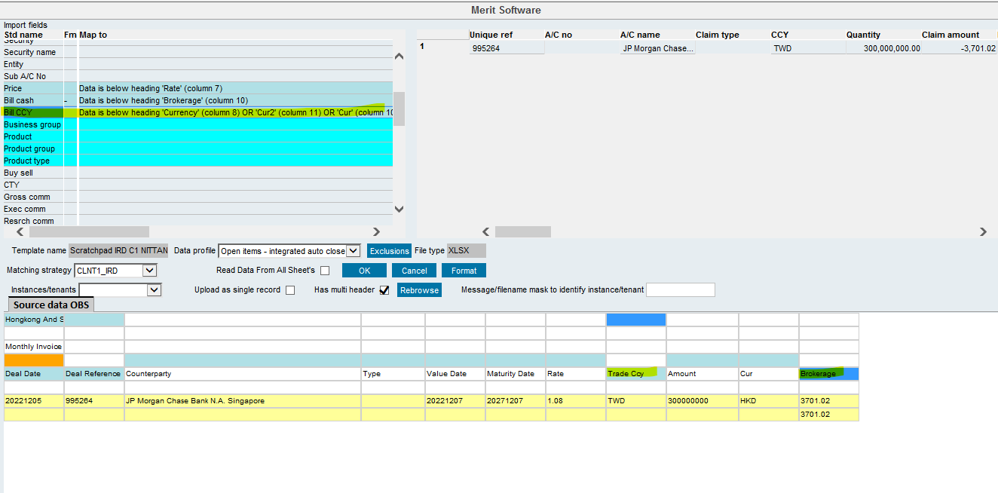
- Now click on ok. And again, go to the scratch pad in import templates and give right click and copy the new patch and paste it in the new patch tab in the ticket number folder we have created and share the patch with user from the Zendesk ticket now.

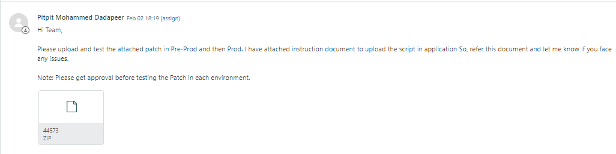

Note: After providing new patch to requester for a new or Modified existing Patch, we need to request user to take approval from his manager before he tests in all environments.

- Once user tests the patch in all the environments, take confirmation and close the Zendesk and related Jira tickets by pasting user comments.

