Barclays – FTT - French Declarations not Recalculating after Merging

- Whenever support receives an incident from Barclays client on FTT product for French declarations not recalculating after merging issue. Support team has to connect with the Barclays affected user and guide them the below steps to fix the issue

Steps to Guide the user:

- Firstly, support has to check with effected user’s suitable time window and schedule a call to guide the below steps to fix the issue

- Once we join the call with user, we need to request them to stop the INVCALC and BACKPOP services in the FTT Manager server

- Next request them to Disable the Invoice Re-calc stages (5000), 6490, and 6500. So that the declarations can be prioritized

- Now suggest user to login into the thick client application - Static data - System option - Daily import scheme - Search with Daily imp as "INVCALC" - select stage 5000 and click on Delete button on the top - click ok. Follow the same process and delete the 6490 and 6500 stages as well as shown in below screenshots

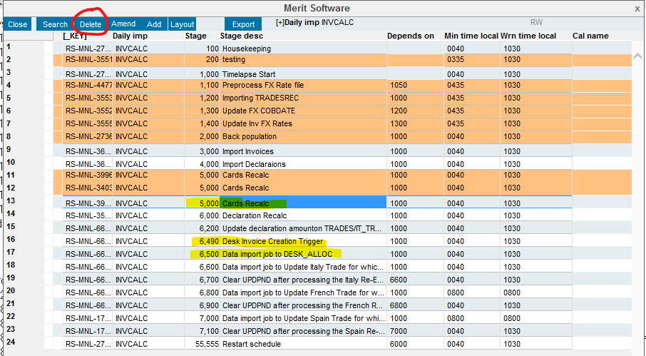

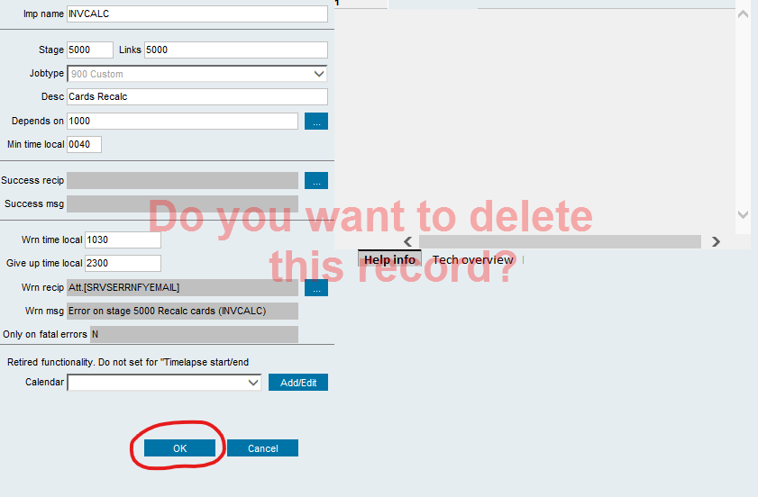

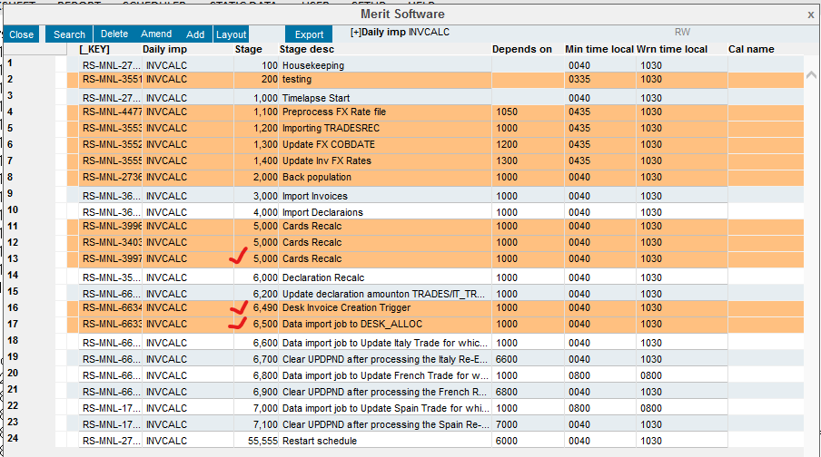

- Now request user close the above window and click on Static data->System options->Service monitor->Flag the INVCALC service->Right click Kill session ->Amend the COB date to the one the service is running -> Click on reset and OK as shown in below screenshots
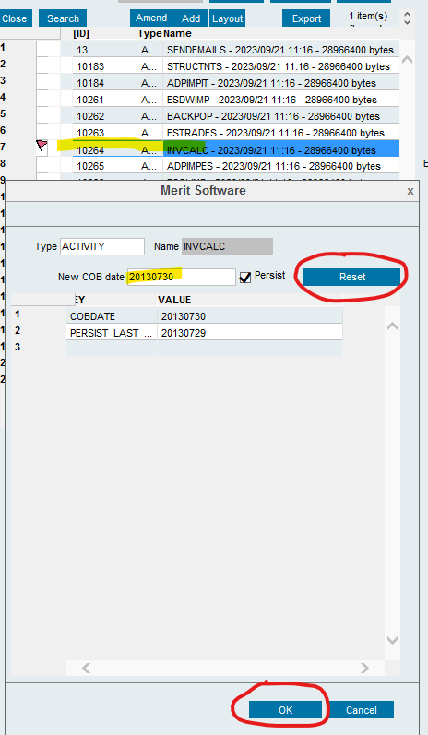

- Now suggest user to start the INVCALC and BACKPOP services. And wait till the declarations got cleared from UPDPND table

- Below is the SQL query to check that. Wait till the records count reduced to zero. If FX rate not found error is coming in the INVCLAC logs for the recent declaration (yet to get FX rate, that will come next day), then ignore that

SQL query: select * from MRT_HFCLAIMSUPDPND where MRT_CARDKEY like ‘DF%’

- Now check the latest INVCALC log file and see if the 6000 stage is currently running or it finished its job. If the stage 6000 is currently running, do nothing, wait till the next stage comes (6200 or 6600)

- If the next stage is running (6200 or 6600) and the count for the above SQL query reaches to zero, then stop the INVCALC service. If FX rate not found error is coming in the INVCLAC logs for the recent declarations (yet to get FX rate, that will come next day), then ignore that

Revert the changes after issue resolved (required declarations calculated):

- we need to request them to stop the INVCALC and BACKPOP services in the FTT Manager server

- Enable stages (5000, 6490 and 6500). Login to the thick client application and go to- Static data - System option - Daily import scheme - Search with Daily imp as "INVCALC" - select stage 5000 and click on Amend button on the top - click ok. Do the same with 6490 and 6500 stages as shown in the below screenshots

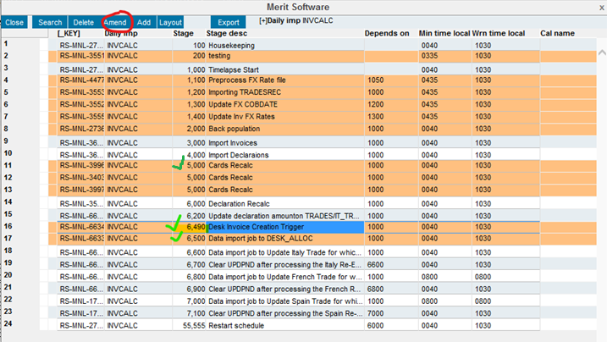

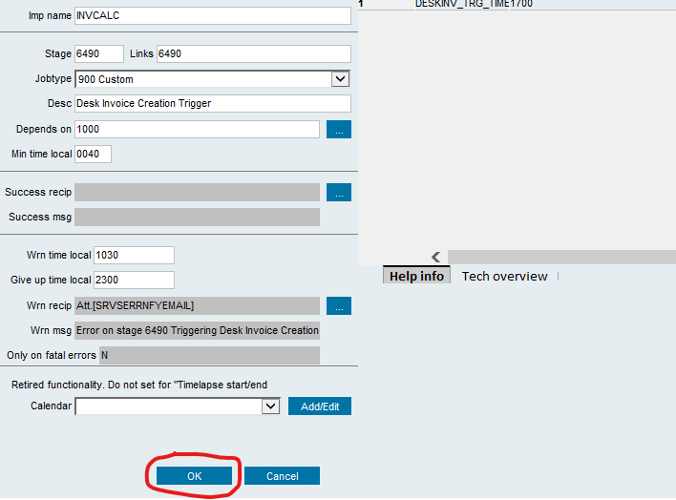

- Now request user to go to Static data->System options->Service monitor->Flag the INVCALC service->Right click Kill session ->Amend the COB date to the one the service is running -> Click on reset and OK

- Now request user to start the INVCALC and BACKPOP services in FTT Manager server.

