CLAIMS MANAGER / Issues with FI Scheduler

- Whenever support team receives the UBS – Claims Manager Issues with FI Scheduler as shown in below screenshot, we need to follow the below steps

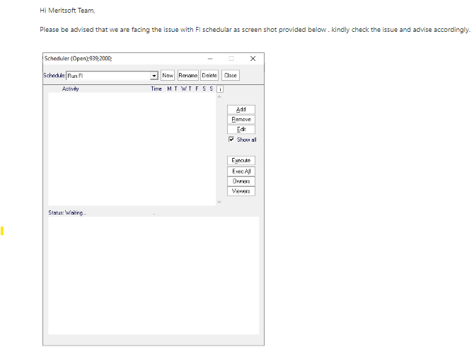

Steps to follow and fix the issue

- GO to SCHEDULER and select “Run FI” scheduler

- Click on the Add button and select the “Script” button as shown below

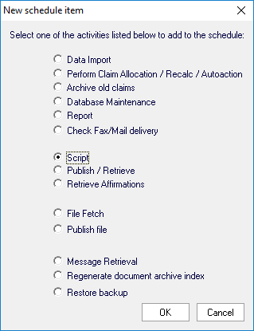

- Click OK and remove all the lines on the dialog.

- Paste the contents of the attached “runfi.txt” as shown below:

Option explicit
Dim errmsg : errmsg=""
Function Script()
msWaitExec "Schedule","Str.[BPATH]"&"INSTALL\FI\CMUBS_IC_SERVICE_FI.EXE","SERVICE=CMSRVRUBS_IC_SERVICE_FI-1",1
Script=true
End Function
ss "rval",Script()
ss "errmsg",errmsg

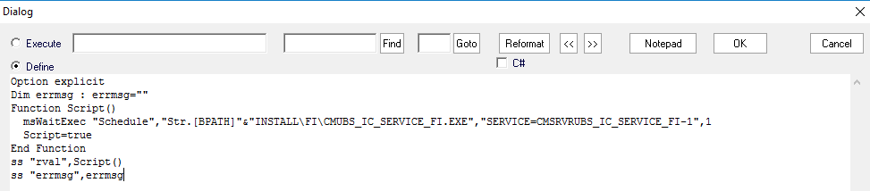

- Click OK.

- Double click on the “Script” scheduler created and rename it to “Run FI”

- Ask users to check if they see the schedule.

