Request for NSTP report

Request for NSTP report:
A report is required to extract open OTC trades for a month, covering both bank-side and broker-side data

Steps to extract the NSTP report for the Broker and Bank side data.
- Open MSSQL
- Go to the Query in the patch and double click the NSTP Broker and bank sql file- “NSTP Broker.sql”, “NSTP Bank.sql”
- 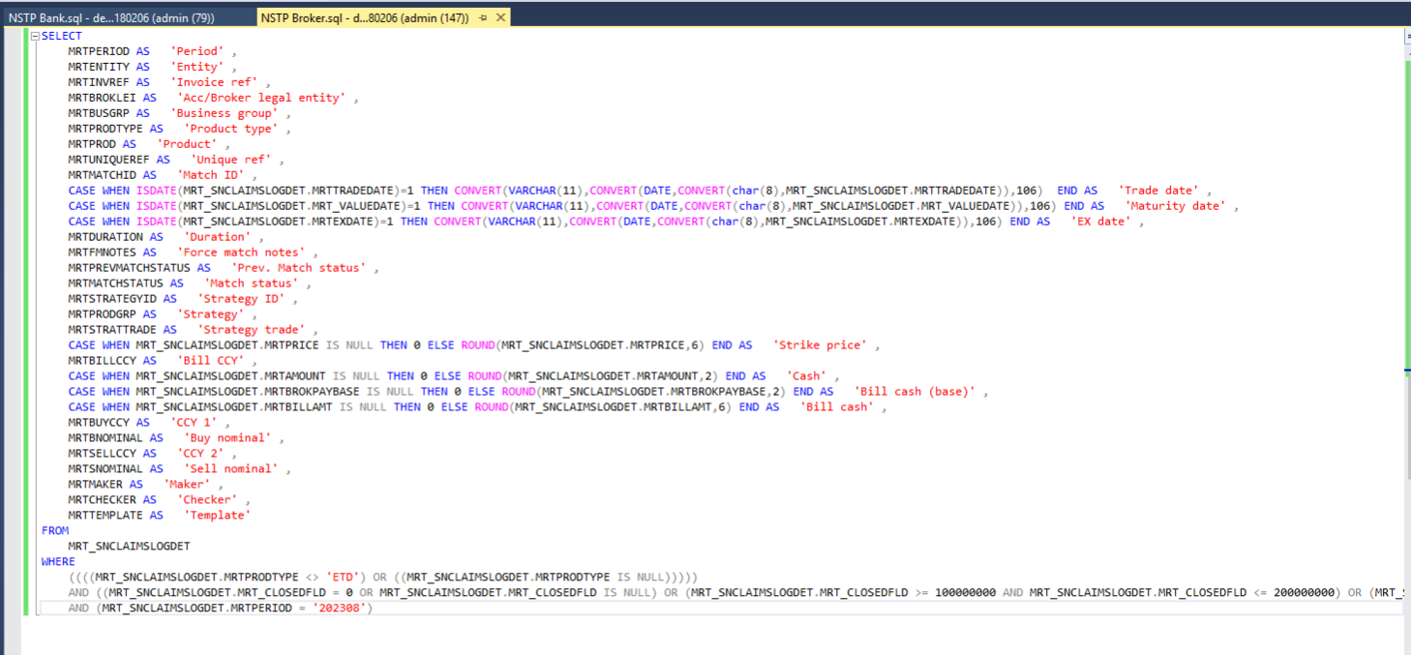
- Verify the Query and click on execute.
- For going forward please refer this query to extract the report by changing the period [MRTPERIOD] for the request month for both bank and broker side and please refer below image for changing the period.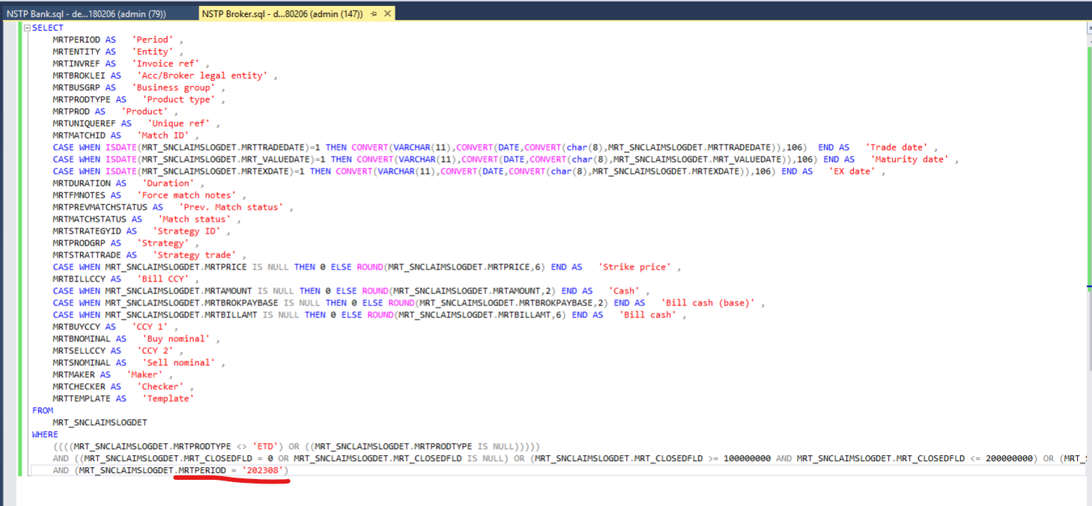
Note: Please run it during off working hours and if there is any requesting with high priority, please reach to us.

