SFTP Login Procedure for CTSOPS:

Open Winscp from the Workspace desktop
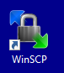
Enter the hostname and PPK
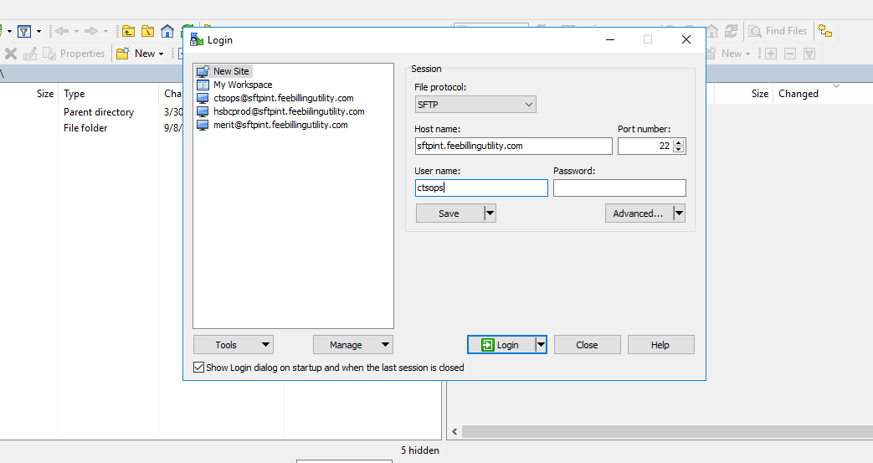
Step 3 ) Click advanced Authentication Private key file -> D:\ctsops.ppk
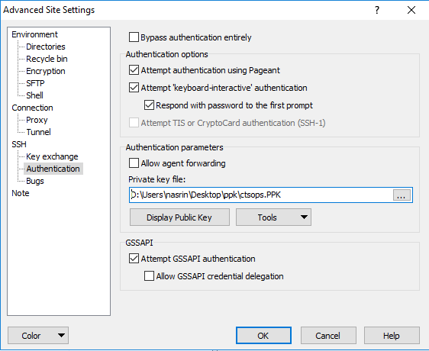
Step 4) Click Ok and Save it.
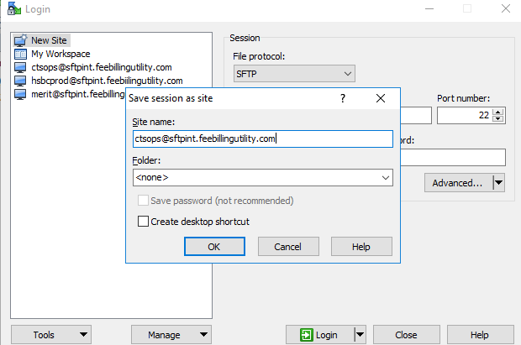
Step 5 ) ClickOk Login
SFTP path
OTC
OTC file path(Path of file received from hsbc)
/brokerage/hsbcprod/TradeData
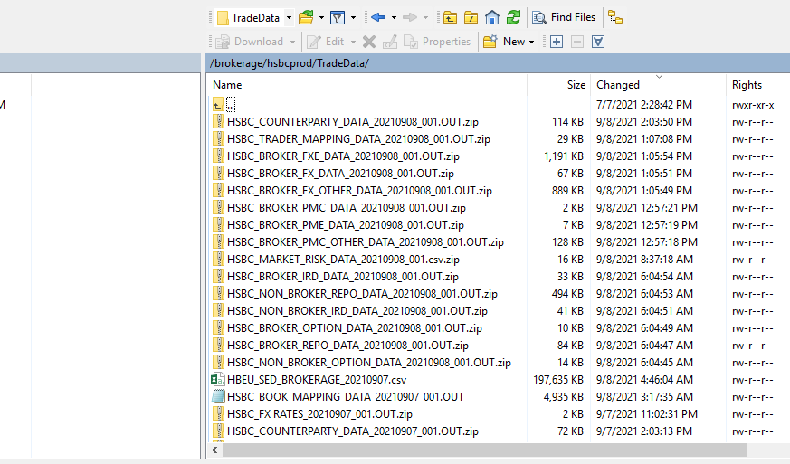
OTC application folder path in Merit(path where trades files are copied in Merit server)
D:\Merit\DATA\CLNT1_1
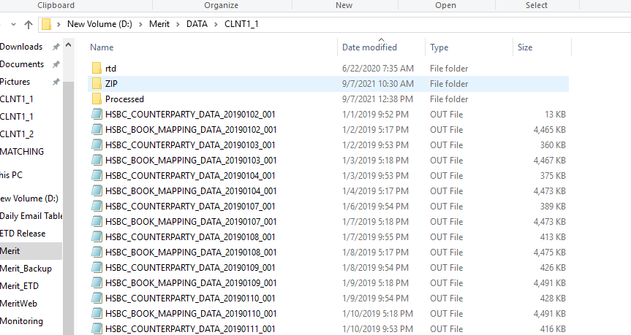
Types of fie we receive in OTC and Products in PROD:
FXO/PMO
HSBC_COUNTERPARTY_DATA
HSBC_FX RATES
HSBC_BOOK_MAPPING_DATA
HSBC_COUNTERPARTY_DATA
HSBC_BROKER_OPTION_DATA
FXV
HSBC_COUNTERPARTY_DATA
HSBC_FX RATES
HSBC_BOOK_MAPPING_DATA
HSBC_COUNTERPARTY_DATA
HSBC_BROKER_FX_DATA

FXE
HSBC_BROKER_FXE_DATA_20200520_001.OUT
HSBC_BOOK_MAPPING_DATA_20191101_001
HSBC_KDB_FX_CASH_DATA_20200129_001.OUT
HSBC_TRADER_MAPPING_DATA_20200413_001.OUT
HSBC_COUNTERPARTY_DATA_20200131_001.OUT
HSBC_FX RATES_20200512_001.OUT

IRD
HSBC_BROKER_IRD_DATA
HSBC_Counterparty_data
HSBC_FX_RATES
HSBC_MARKET_RISK_DATA
HSBC_TRADER_MAPPING_DATA
HMS Book mapping file

PMC (Not in PROD it is still in UAT)
HSBC_BOOK_MAPPING_DATA
HSBC_COUNTERPARTY_DATA
HSBC_FX RATES
HSBC_BROKER_PMC_DATA

Types of Issues in OTC
If trade file is missing in sftp
- First contact Nasrin and if file is also not received in hsbc Sftp
- If file is present in hsbc sftp then copy manually the required file in application folder.
- If file is also missing from hsbc sftp then send out an to below DL:
tlmproductionsupport.gbm@hsbc.com

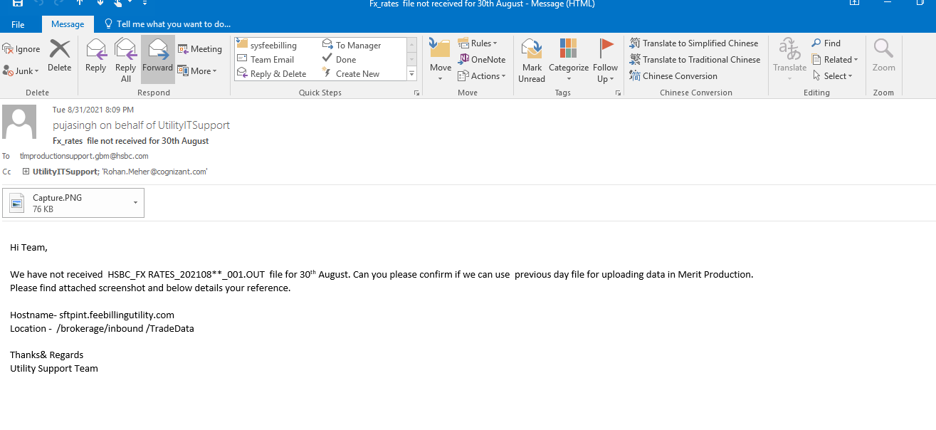
If Trades not uploaded in Merit
We send out an email to the Merit team(production.support@meritsoft.com) with CLIENT1_1 logs.

ETD
ETD file path(Path of file received from hsbc)
We have 3 regions in ETD US,Europe,Asia and all the files will be there in their respective folder.
If you want to check the previous days for all the regions that will be present in
Below path:
/brokerage/hsbcprod/ETD/Archive

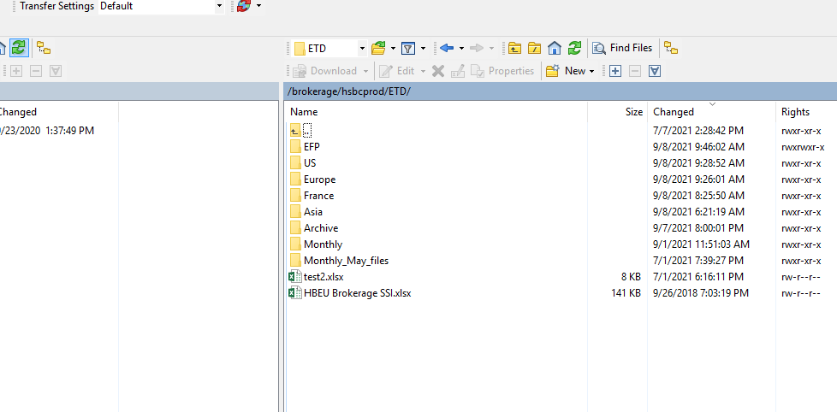

In ETD we have 14 files for each of the region.
Types of issues in ETD:
If trades are missing
- First contact Nasrin and if file is also not received in hsbc Sftp
- If file is present in hsbc sftp then copy manually the required file in application folder.
- If file is also missing from hsbc sftp then send out an to below DL:
hts.gbm.futures.it.rtb.bo.us@hsbc.com , hts.tlm.etl.level3.support@hsbc.com
If Trades not uploaded in Merit
We send out an email to the Merit team(production.support@meritsoft.com) with CLIENT1_2,Asia,Europe,US logs.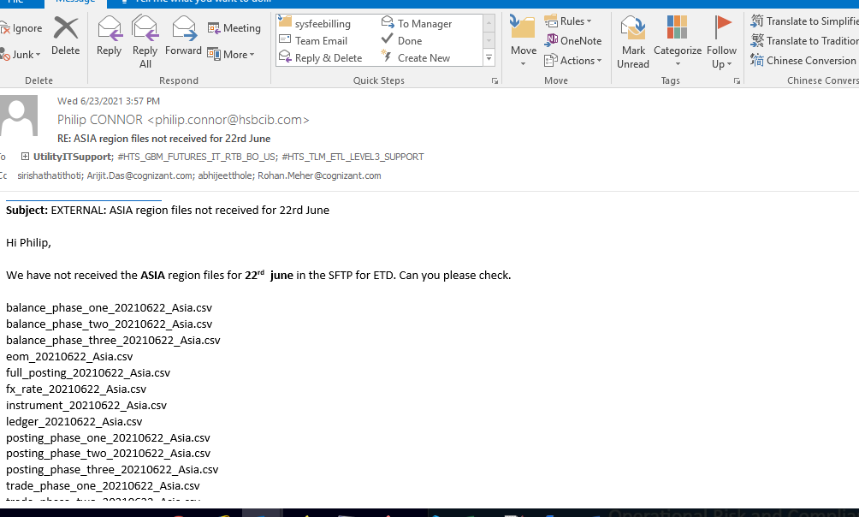

SFTP Login Procedure for Merit Release Packages:
Step 1 ) Open Winscp from the Workspace desktop
Step 2 ) Enter the hostname
Step 3 )Download the release package from SFTP extract using password provided by Merit.
Using below credential.
releases.sftp.cognizantproducts.com
Port 22

MER_HSBC_UAT_User2
Kt.(7]yHEF_'`Ln

MER_HSBC_PROD_User2
bN45[FZ64vUU!<u

