How to create a Jira Ticket

- Jira ticket can be created in two ways. One I through Zendesk and the other is to create from Jira ticketing tool.
- The purpose of creating and mapping Jira ticket in Zendesk is to capture all the updates from Jira to Zendesk tickets. Also, If L3 engineering teams request any further info or if they need any advise to give it to user.

Processing for creating Jira ticket from Zendesk:

- Login in to Zendesk and open the ticket for which you want to create Jira ticket and click on apps options on top right corner of incident or task form and then click on Create Issue as shown in below figure.

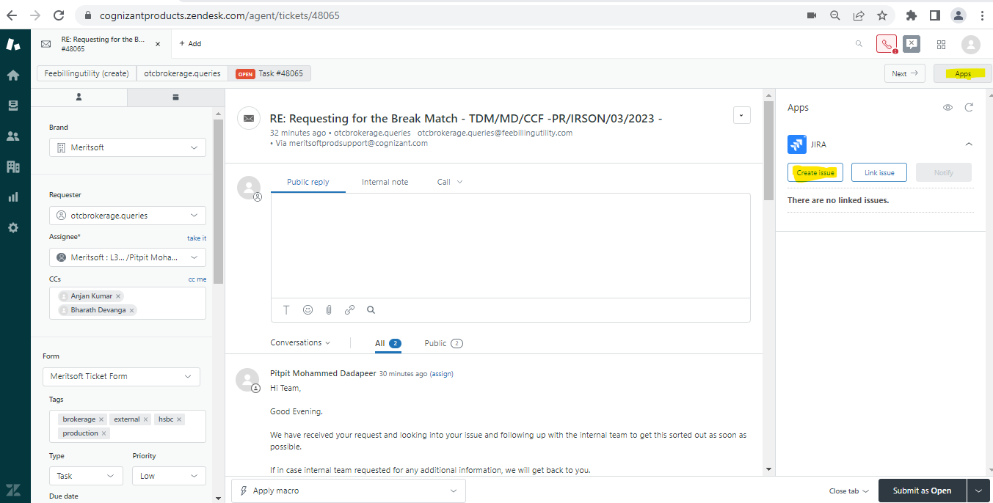

- A window will be populated as shown below to fill up all the details related to the current issue.

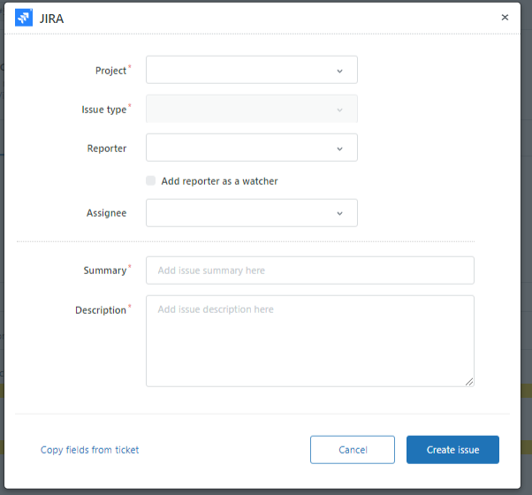

- We need to fill all the details like Project name (Meritsoft MER), Issue Type (Incident – Bug, Task or question – Task), Reporter (Your name), Issue short description with Zendesk ticket number, Description (The exact issue reported by Client) and Priority (Choose accordingly) as shown in below screenshot.

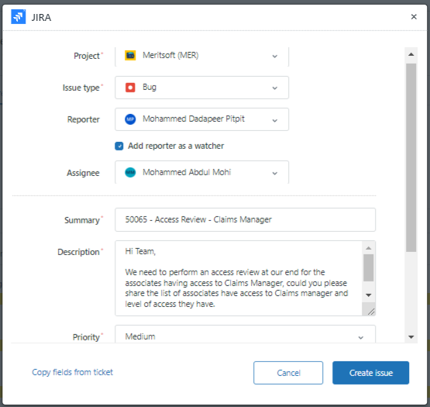

- Note: If we are creating Jira ticket through Zendesk ticketing tool, we need to go to the Jira ticket created and need to add few more fields like Components, Labels, attachments, Sprint, Client, and Environment.

Processing for creating Jira ticket from Jira Tool:

- If we want to create a Jira ticket from Jira ticketing tool, we need to access the below link and click create. https://cognizantproducts.atlassian.net/browse

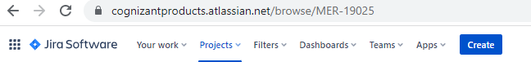

- Once we click on create in Jira a window will be populated as shown below, we need to fill all the required details.

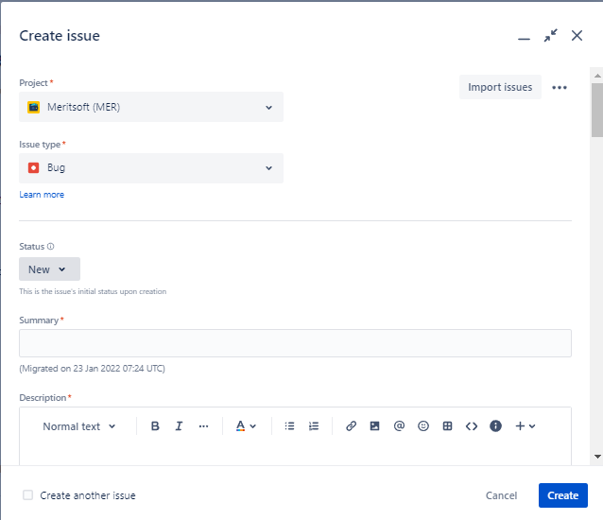

- Project will be by default, Meritsoft (MER), Issue Type will be Issue Type (Incident – Bug, Task, or question – Task), Status will be New by default, Summary (Zendesk Ticket ID – with Subject line), Description (The exact issue reported by Client). The next fields as follow.

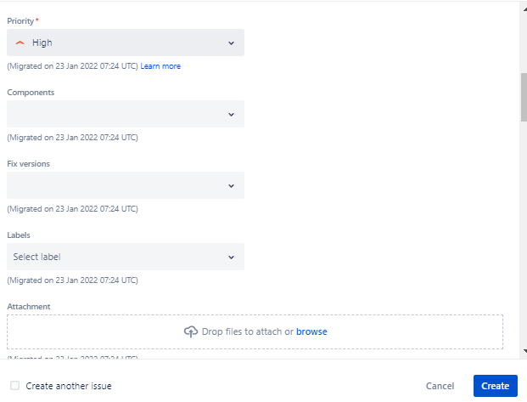

- Now choose priority accordingly, Components must be chosen depending upon the Client and Product and loop Prod Support as well, we can Ignore Fix versions, For Labels choose the Client name and Support team as well. If the Client has provided any attachments like error screenshots, or query results, attached them by clicking on browse.
- Now choose respective Client name and Environment. Assignee Should be Srijina for Brokerage tickets, other respective L3 engineers for other products.
- Apart from these fields in the Jira creation form, choose N/A or other options if it is a bug
- If it is a task, then it will not ask us for the other options.
- Once all the details are given in the Jira Click on Create on the left bottom as shown in below screenshot
- Irrespective of all the Clients and Products for all Jira’s we create for Engineering Team. We need to tag Tech Consultancy Team in CC.

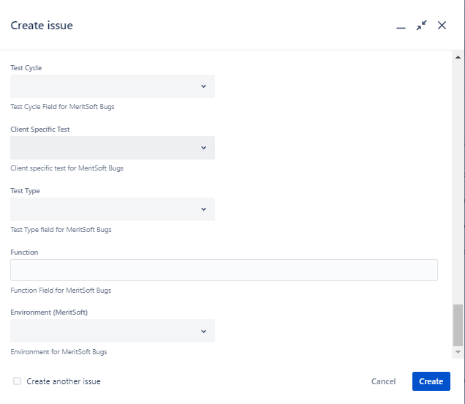

- Once we click on create a pop up will come as open Jira on left corner of Jira tool. Open it and link it in Zendesk ticket as shown below

