Severity 1 Ticket Process to Follow

Whenever we have any Severity – 1 (Urgent) ticket for any Merit Client with any of the merit product as shown below, please follow the below instructions.
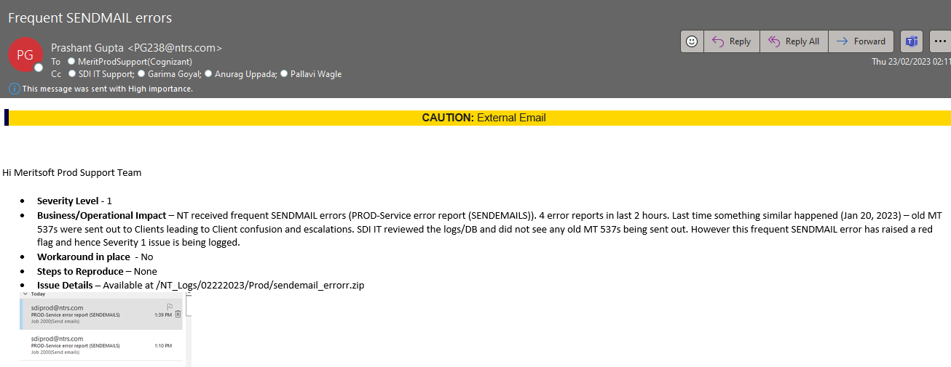
- Support team receives an email from Client as seen in the above screenshot that this issue will be a severity 1 ticket
- Few of the clients will not mention as Severity 1, they will just mention as Critical as shown below screenshot

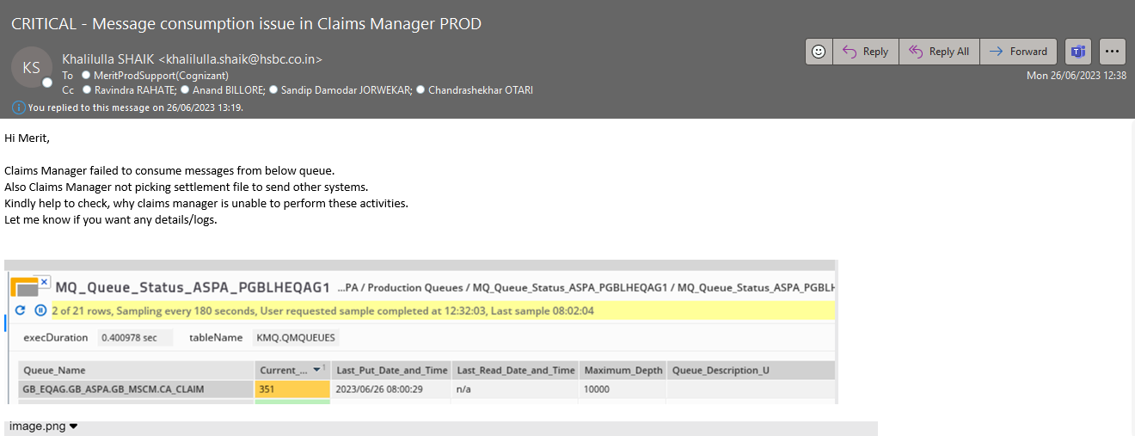

- In this scenario, we need to analyse the issue and try to understand if the issue qualifies for a Severity 1 ticket depending upon the business impact and users impacted. If you are not sure about the Criticality, then straight away reach out to engineering team and get confirmation and proceed further.
- When we have received anu Severity 1 ticket, firstly we need to triage that ticket in Zendesk with proper attributes. And then create a Jira ticket for that issue
- Once we triage the ticket and create Jira, we need to send a Severity 1 notification to the respective L3 engineering team by looping Product and Account Owners as shown in below screenshot
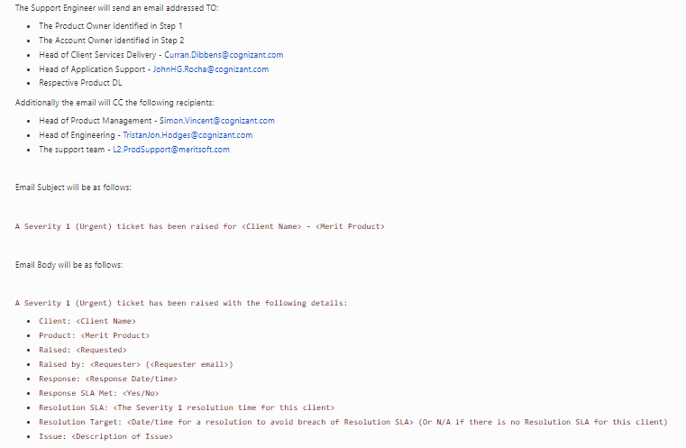

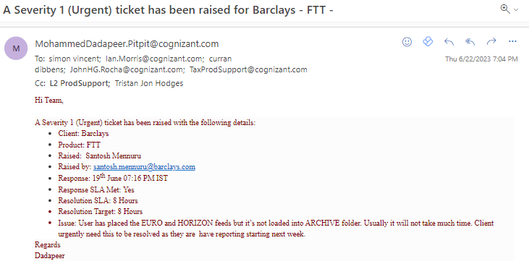

NOTE: We need to send this email through Cognizant mailbox

- We can get the Account owner, Product Owner, and SLA from the below Confluence Links
- Escalation Metrics - https://cognizantproducts.atlassian.net/wiki/spaces/MER/pages/43483137/Escalation+Process
- SLA Metrics - https://cognizantproducts.atlassian.net/wiki/spaces/MER/pages/11404293/SLA
- After sending a notification email to the Account and Product owner along with necessary participants, we need to create a severity 1 chat channel in Microsoft teams as shown in below screenshot

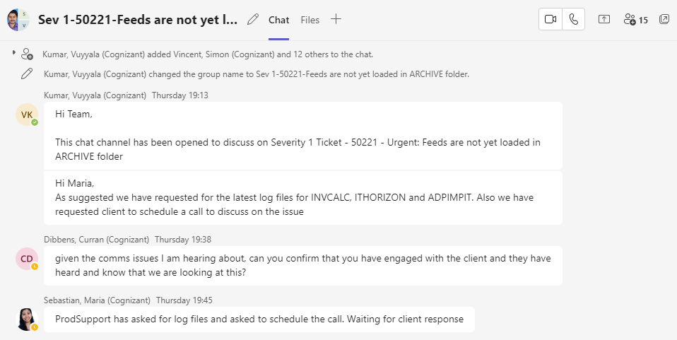

- Once we create the chat channel in Microsoft teams, we need to add all the respective product engineering team, support team, account, and product owners in the chat channel
- After adding them in the channel, we need to inform in the channel that this chat channel has been created to discuss on the ongoing Severity 1 ticket and let us know if we need to request any logs or data from Client to proceed further.
- As shown in the above screenshot, Maria from L3 has requested support to get logs from Client to review and proceed further investigation
- Every update from Client and Engineering team must be captured in Zendesk ticket and as well as in Jira ticket
- If we need any of the information from Client, we need to send follow up emails on daily basis through Zendesk
- Any update shared by L3 team has to be communicated with Client through Zendesk ticket
- As per the updates from L3 engineering team if the issue is fixed, we need to get confirmation from Client, if we can proceed to close the case.
- If the client is not responding for information or confirmation required, we need to update John, they will set up a call with Client and get the information.
- Once Client confirms that the issue can be closed, We need to close the Zendesk and Jira Tickets and update in the chat channel and we can also close the chat channel.

