HSBC (Cognizant) – Brokerage – ETD Reports – Header NEW FORMAT error

Whenever we receive an error in any ETD region related to Header NEW FORMAT error as shown in the screenshot below. Kindly follow the below steps.
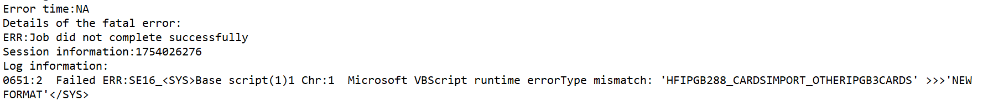

Steps to follow to fix the issue
- Login into the production server 10.84.18.48 and navigate to D Drive – Merit ETD – Data – go to the region folder in which you have observed errors in logs (If you observe error in ASIA region logs, then go the Asia folder)
- In the Asia region folder, we will be having a set of files related to Asia region files as shown in below screenshot
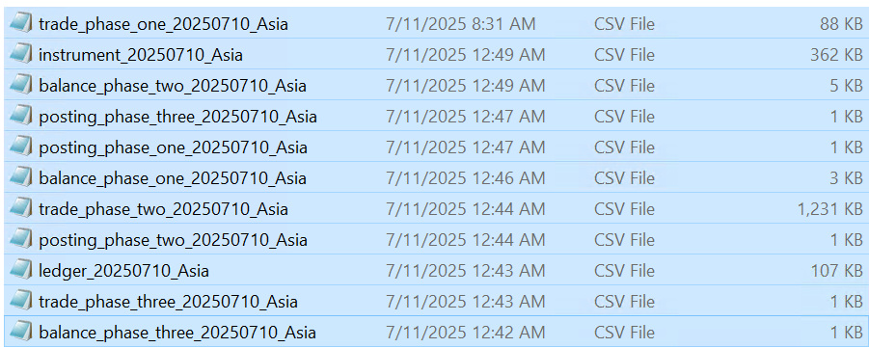
- Now open each file and check if there if we have any header to the files. If you found any header. Copy the file and bring to local desktop in CSV format.
- Open the file and delete the headers and check the count of lines and update it in the end as shown in below Screenshots.
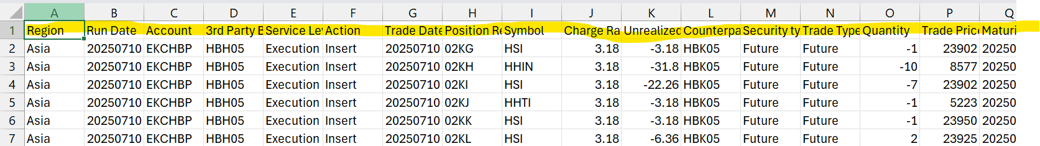

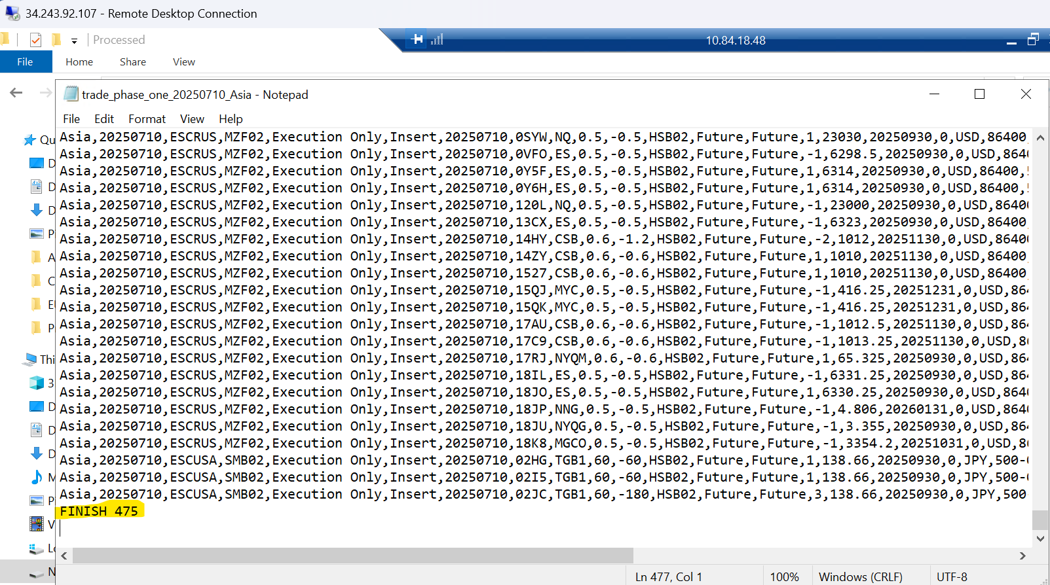

- Now Stop the Asia region service and paste file which is corrected in the path D Drive – Merit ETD – Data – ASIA folder
- Open ETD ThickCleint – D Drive – Merit ETD – Install – Client – ThickClient Application as shown in below screenshot
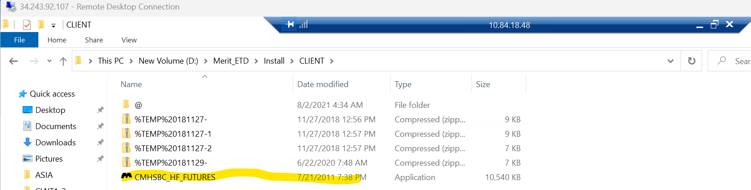
- After opening ETD ThickCleint, navigate to - Static Data - System options – Service Monitor
- Right click on Asia service and do Kill session as shown in below screenshot
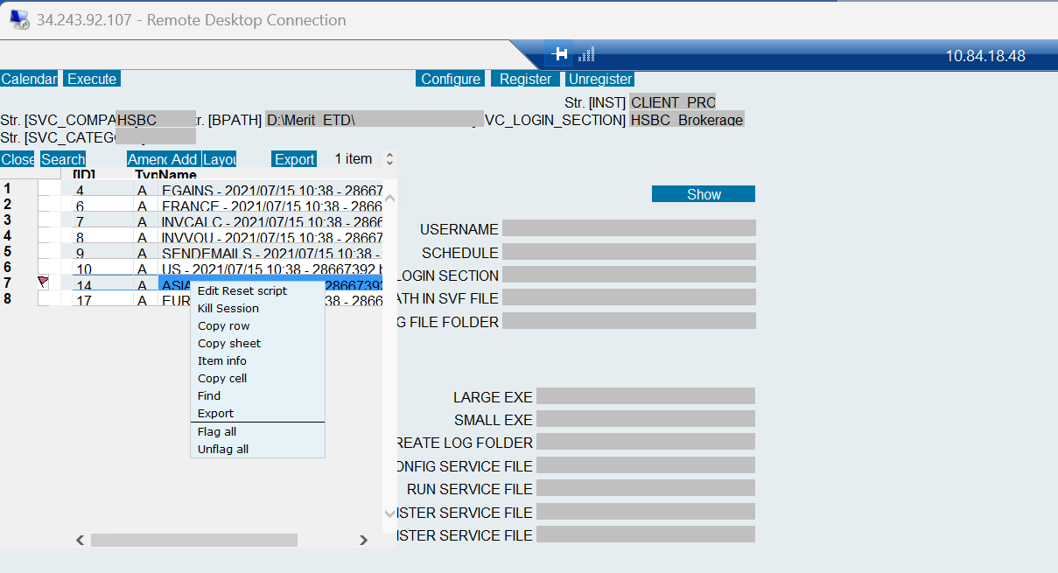
- After doing kill session, Amend the Asia service and edit the cobdate with same date as today -1 and then click on reset and OK as shown in Below SS.
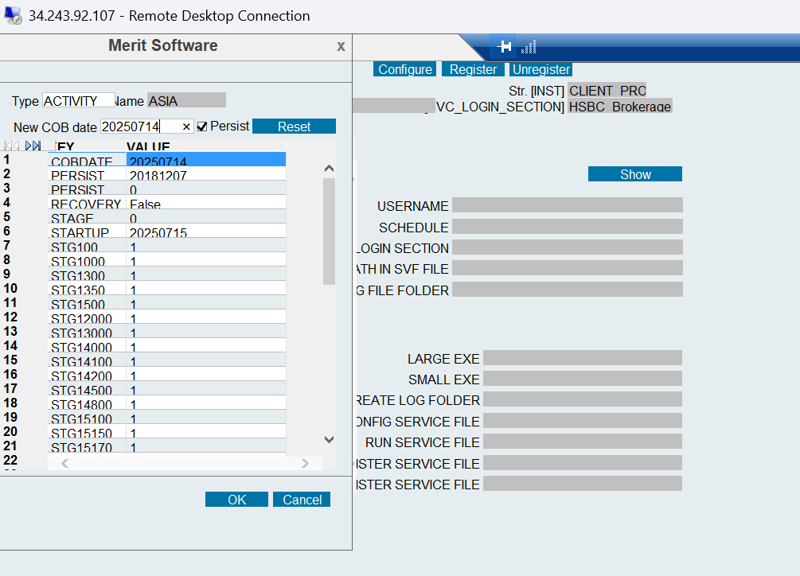
- After resetting COBDATE, now login into SQL DB Prod and change the option to ETD PROD and execute the below queries as shown below
- we need to check the select * from MRT_HFCLAIMSEXP table as below.
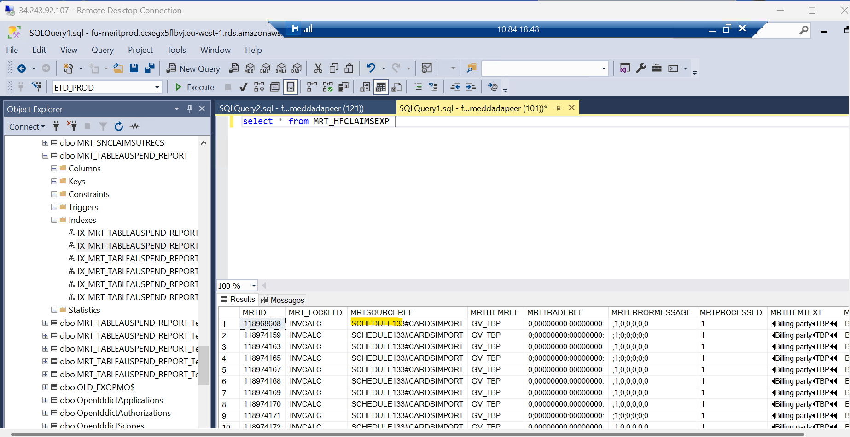
- As shown in above screenshot if you find Other in the place of SCHEDULE. Kindly run the below query to check if there are any source keys related to Other

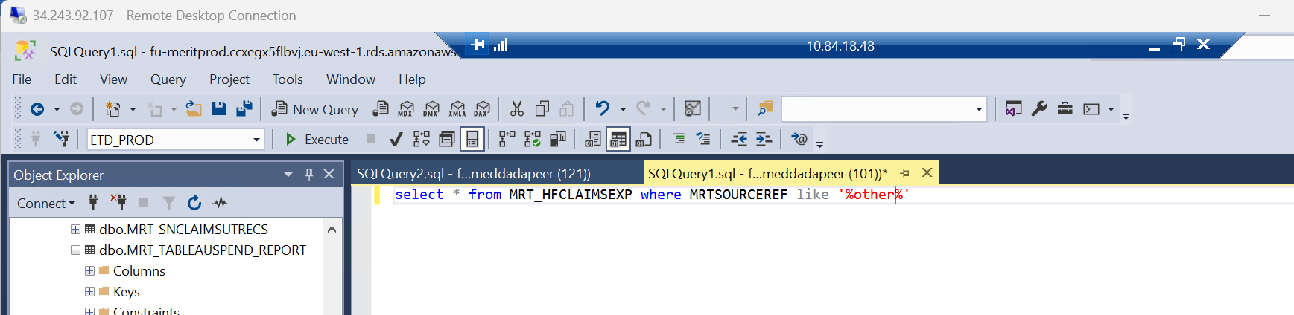

- After running the above query if you don’t find other source ref, just start the region service which we stopped. If you found any other source ref, we should take the mrtid of that entry and proceed to delete it from the exp table.
For example: delete from MRT_HFCLAIMSEXP where MRTID = '118711630'.

- After deleting the entry to cross check run the below query.
select * from MRT_HFCLAIMSEXP where MRTSOURCEREF like '%other%'

- If you don’t find any other entry, Start the service and monitor the region wise logs until the reports are sent to ops team.

